**SQL Lesson 1: SELECT queries 101**

Exercise 1 — Tasks

1. Find the **title** of each film
2. Find the **director** of each film
3. Find the **title** and **director** of each film
4. Find the **title** and **year** of each film
5. Find **all** the information about each film
6. SELECT title FROM movies;

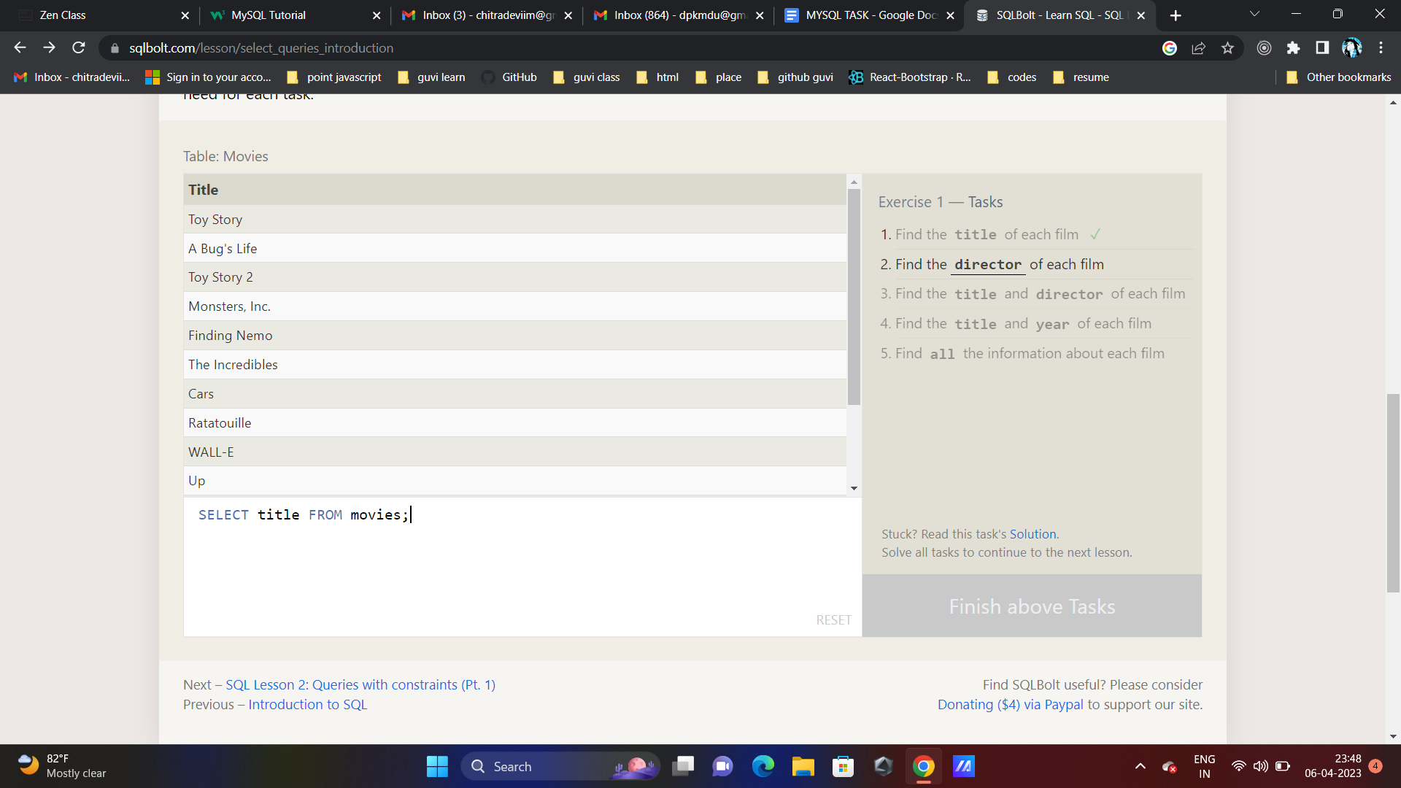

1. SELECT director FROM movies;

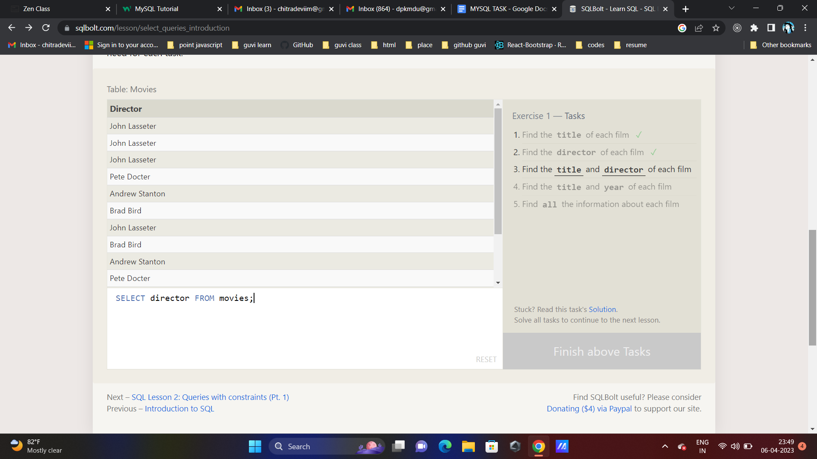

1. SELECT title,director FROM movies;

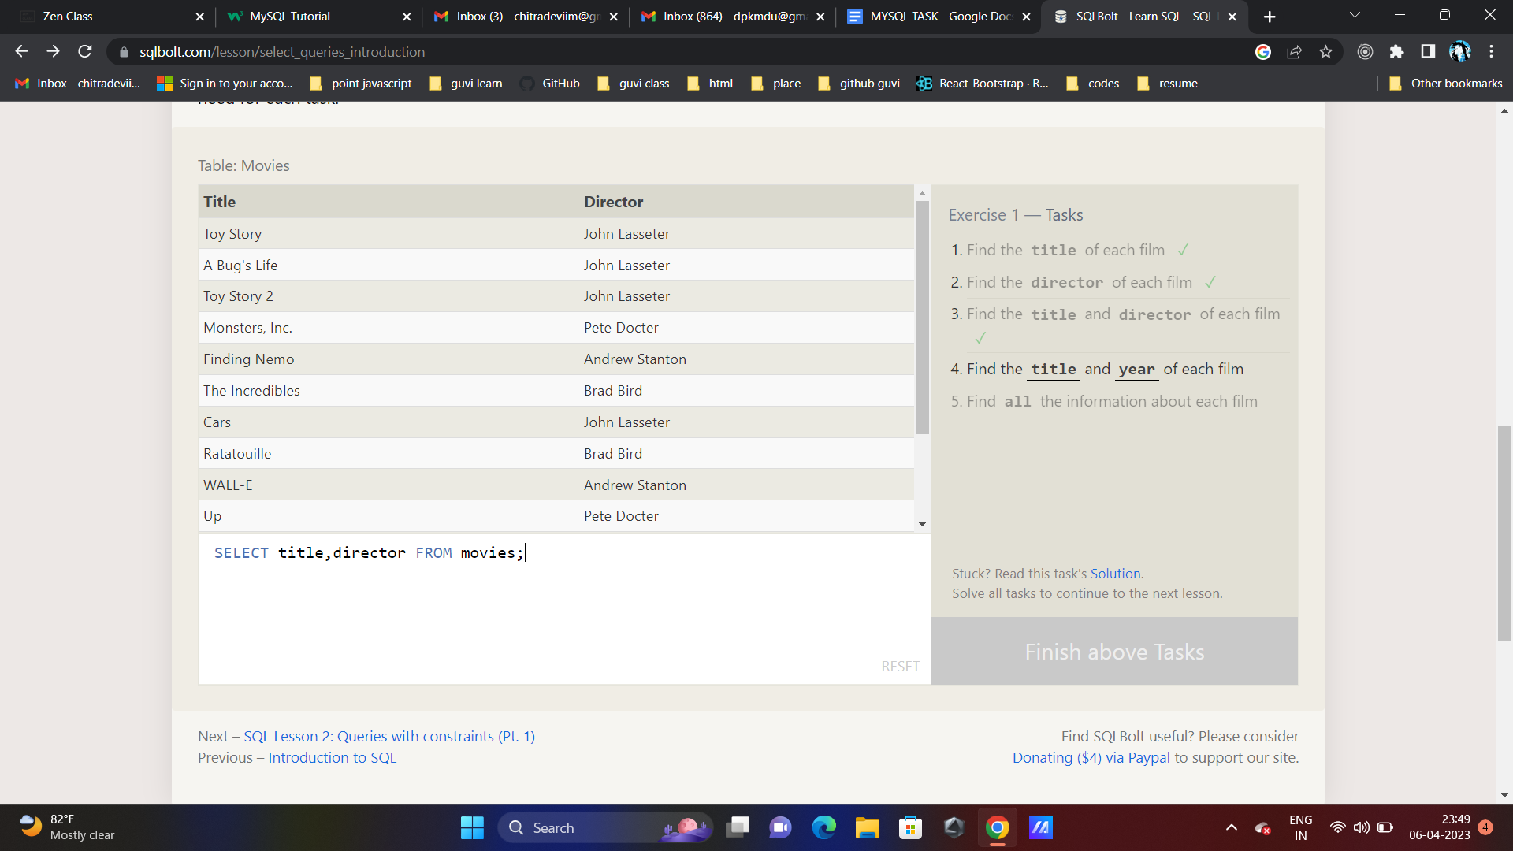

1. SELECT title,year FROM movies;

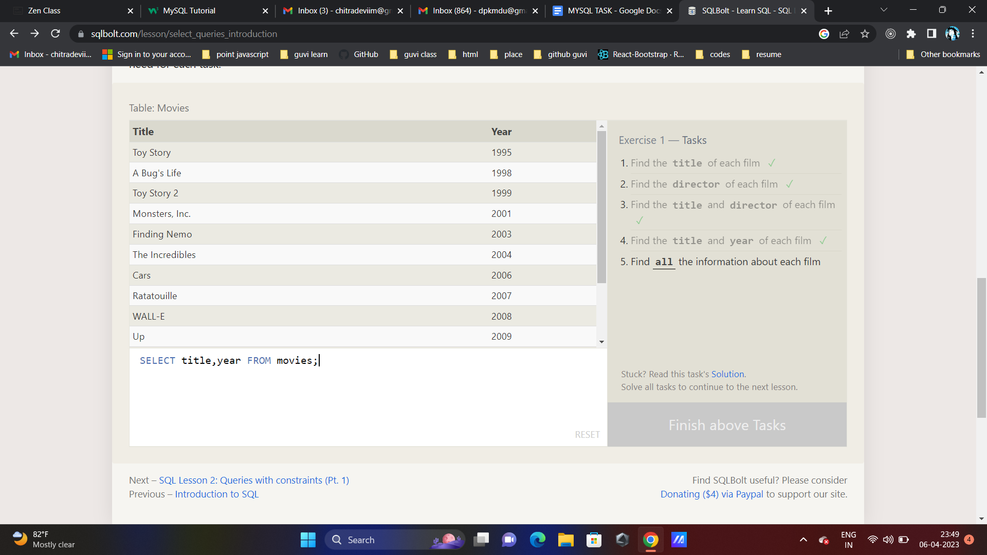

1. SELECT * FROM movies;

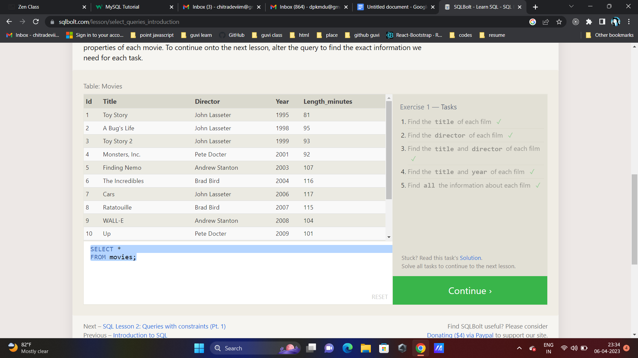

**SQL Lesson 2: Queries with constraints (Pt. 1)**

**Exercise 2 — Tasks**

1. **Find the movie with a row id of 6**
2. **Find the movies released in the years between 2000 and 2010**
3. **Find the movies not released in the years between 2000 and 2010**
4. **Find the first 5 Pixar movies and their release year**
5. SELECT * FROM movies where id=6

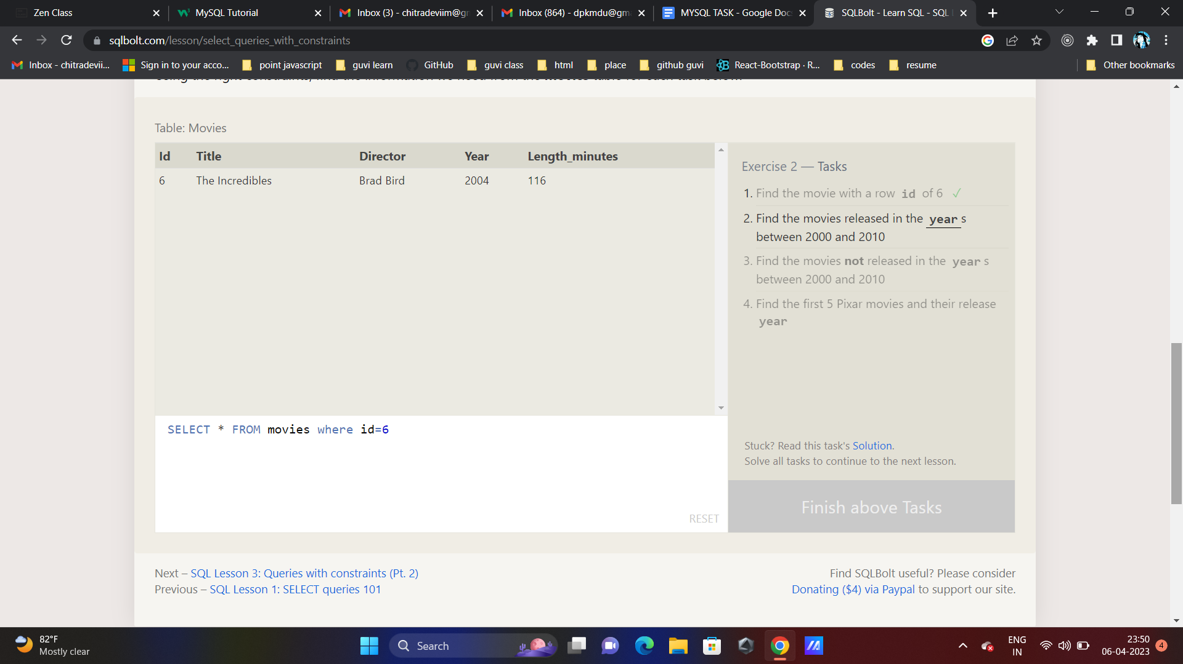

1. SELECT * FROM movies where year>=2000 and year<=2010

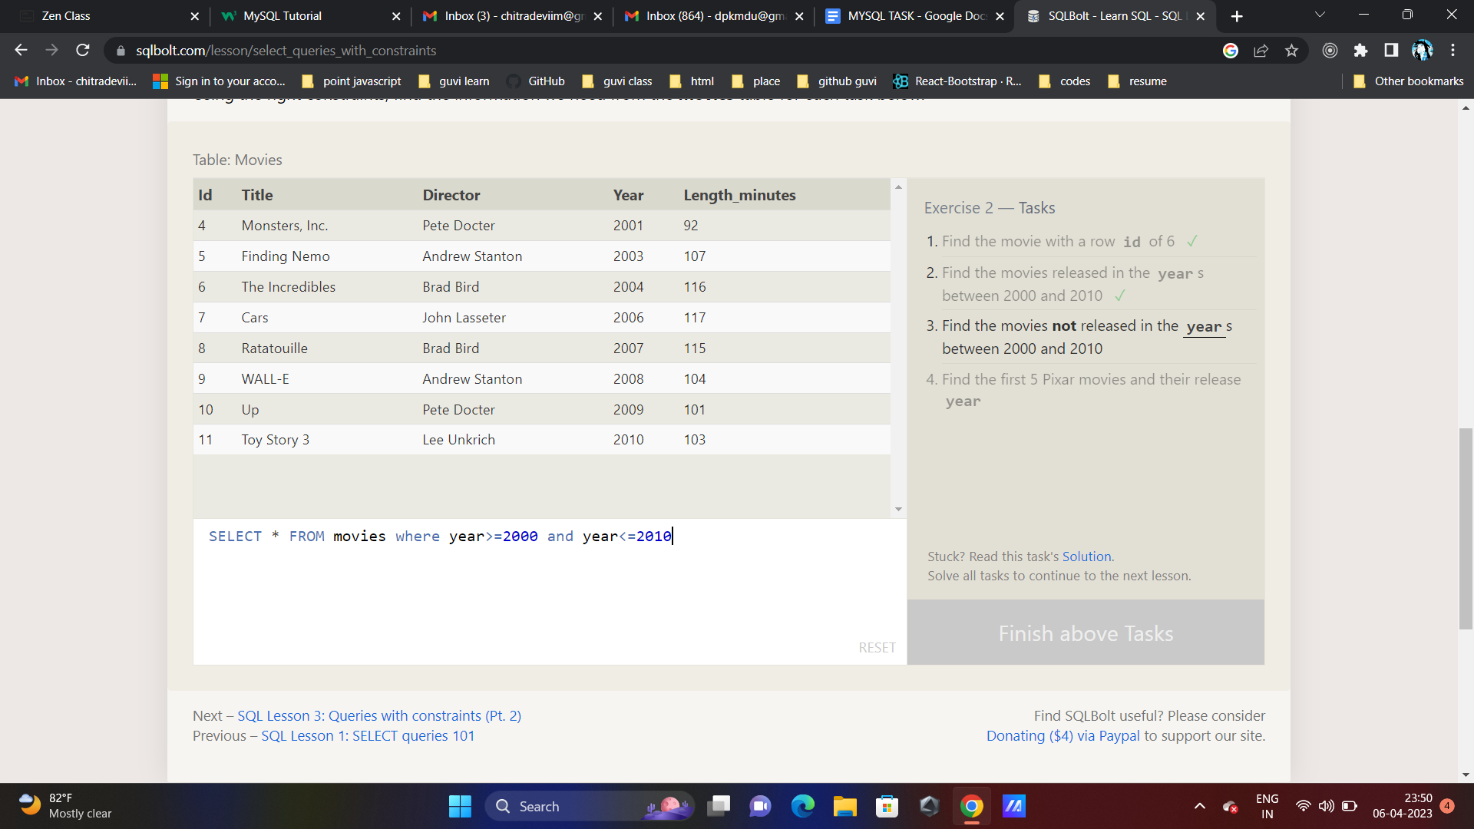

1. SELECT * FROM movies where year not between 2000 and 2010

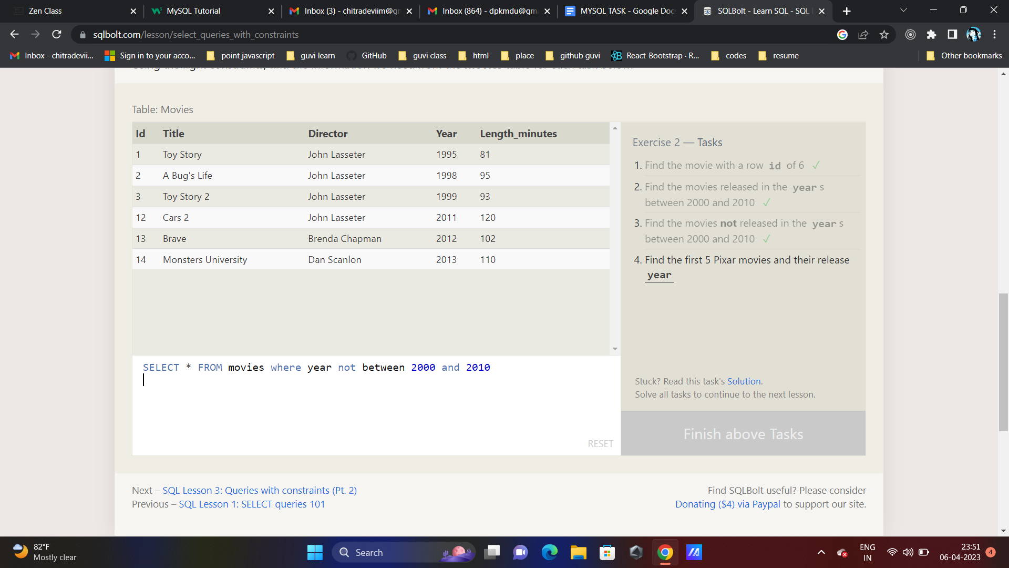

1. SELECT * FROM movies where id between 1 and 5

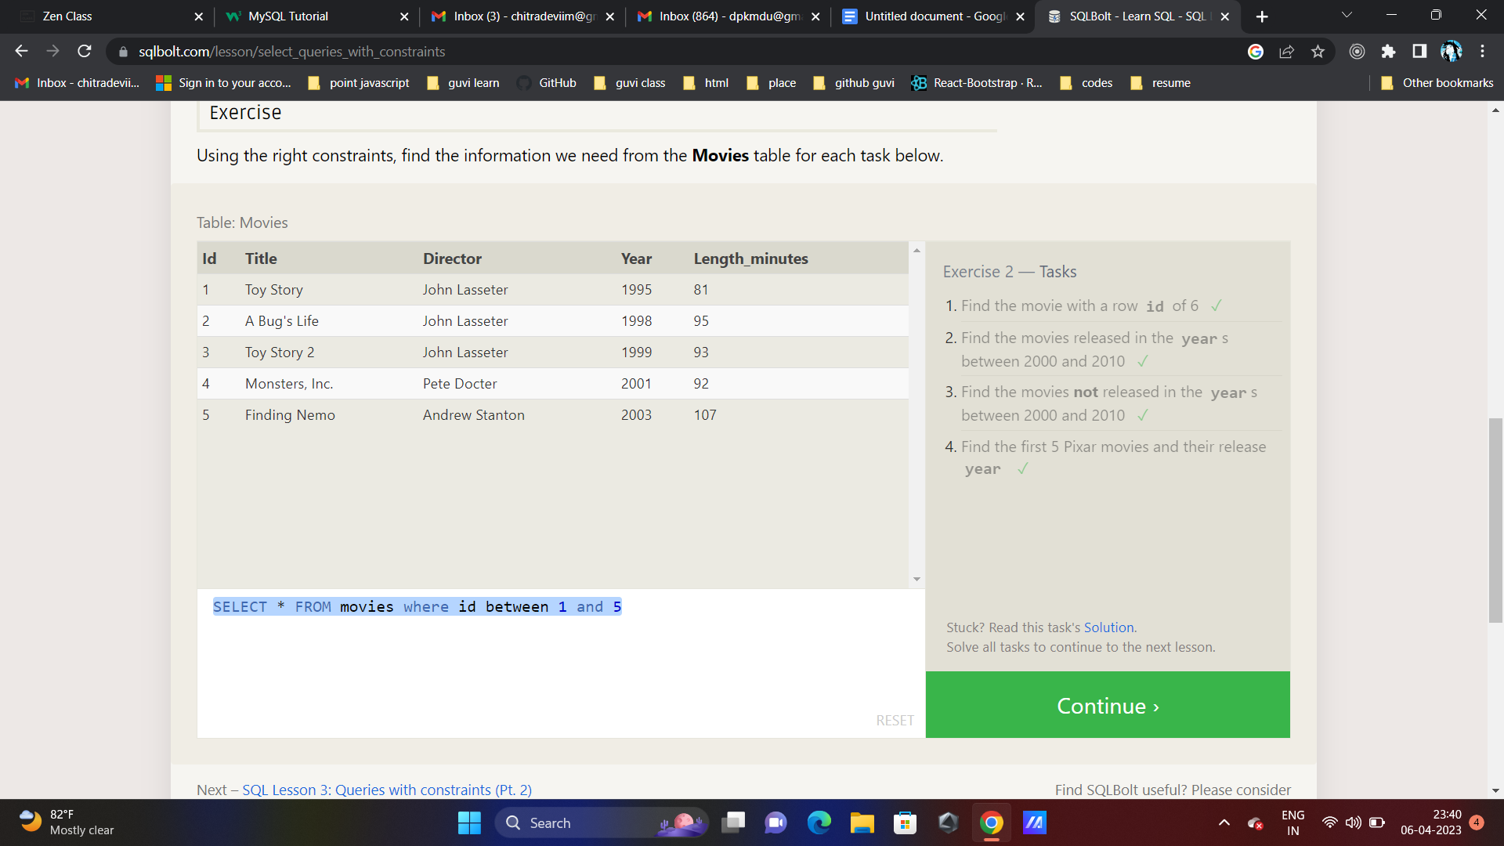

**SQL Lesson 3: Queries with constraints (Pt. 2)**

**Exercise 3 — Tasks**

1. **Find all the Toy Story movies**
2. **Find all the movies directed by John Lasseter**
3. **Find all the movies (and director) not directed by John Lasseter**
4. **Find all the WALL-* movies**

* SELECT * FROM movies where Title like "%Toy Story%"

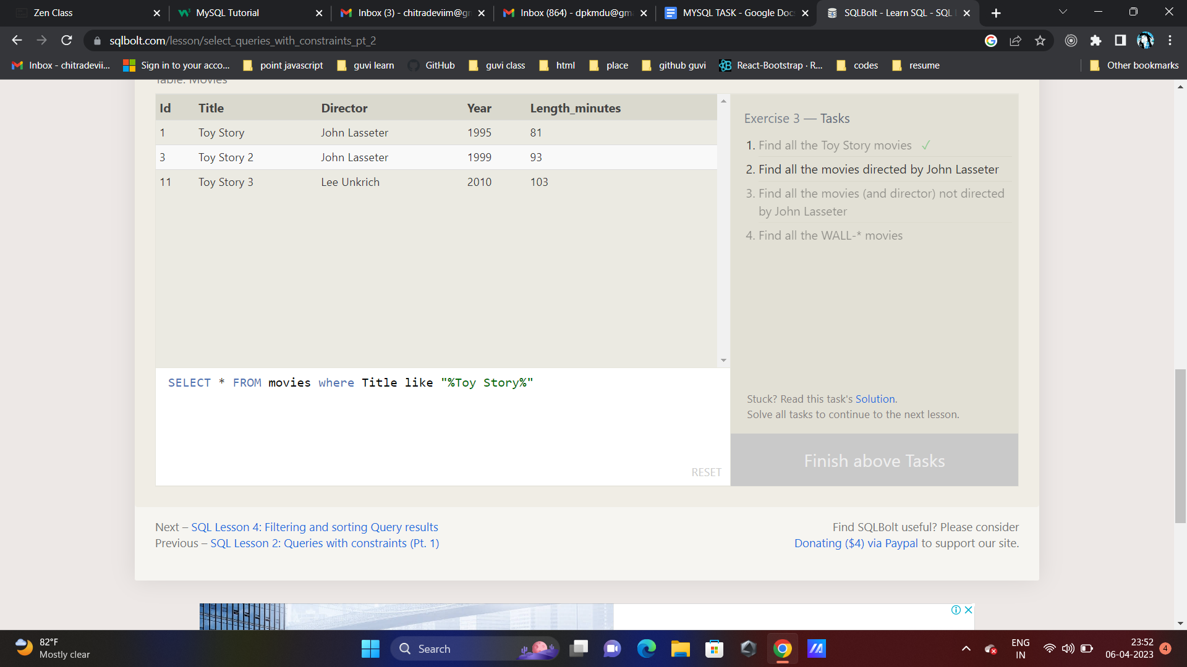

* SELECT * FROM movies where director like "%John lasseter%"

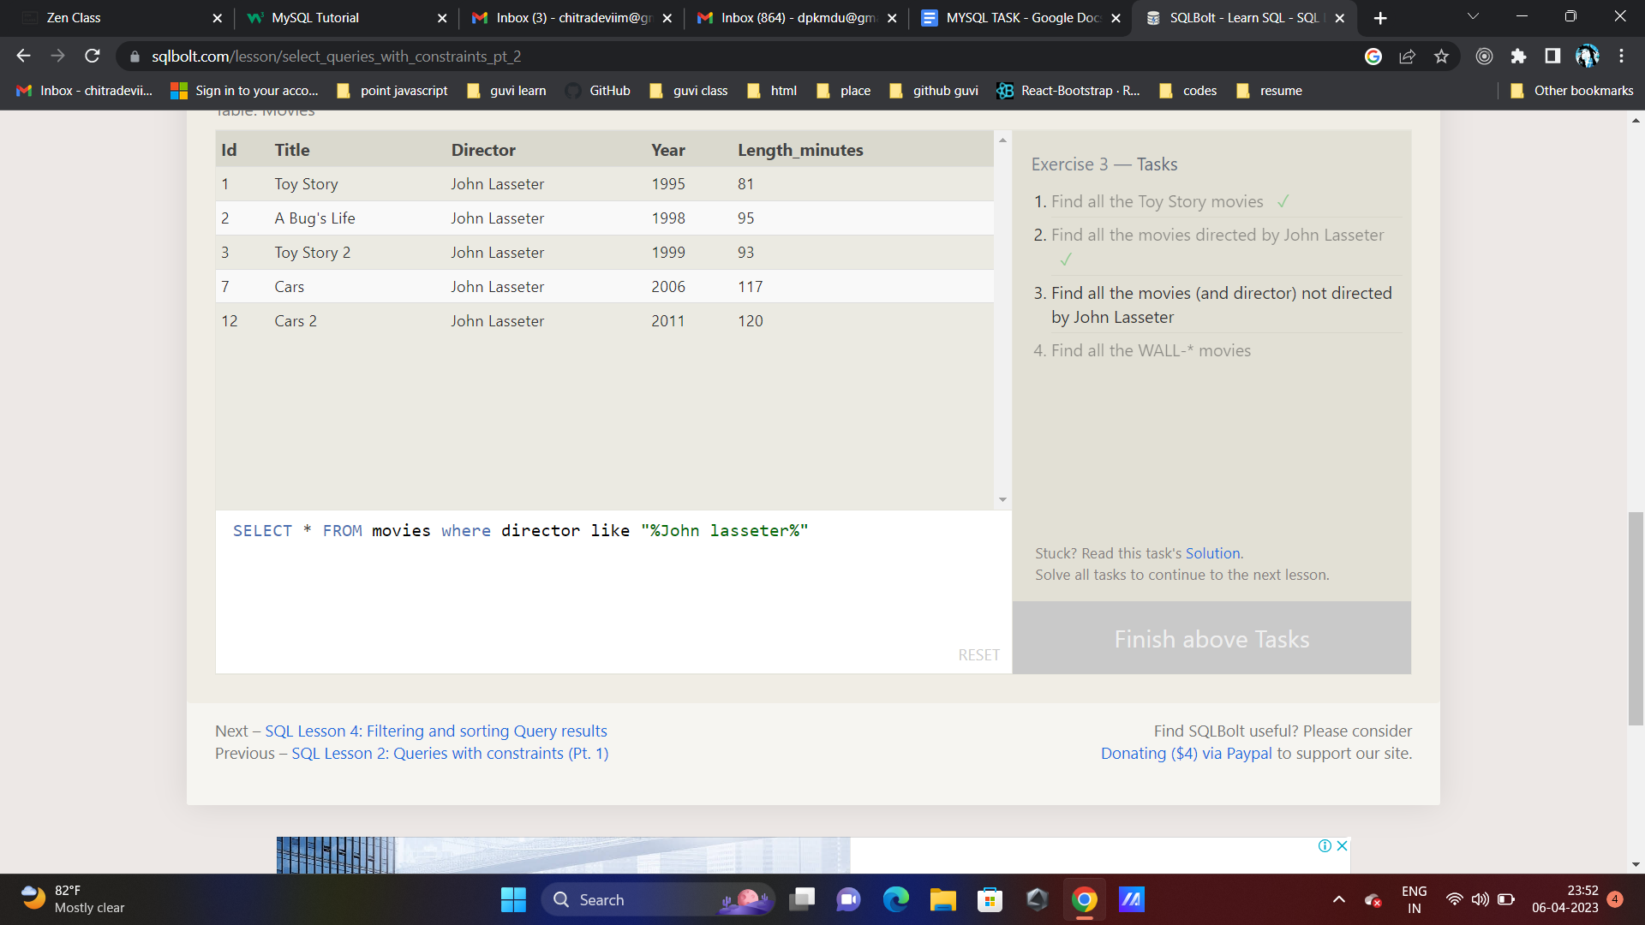

* SELECT * FROM movies where director not like "%John lasseter%"

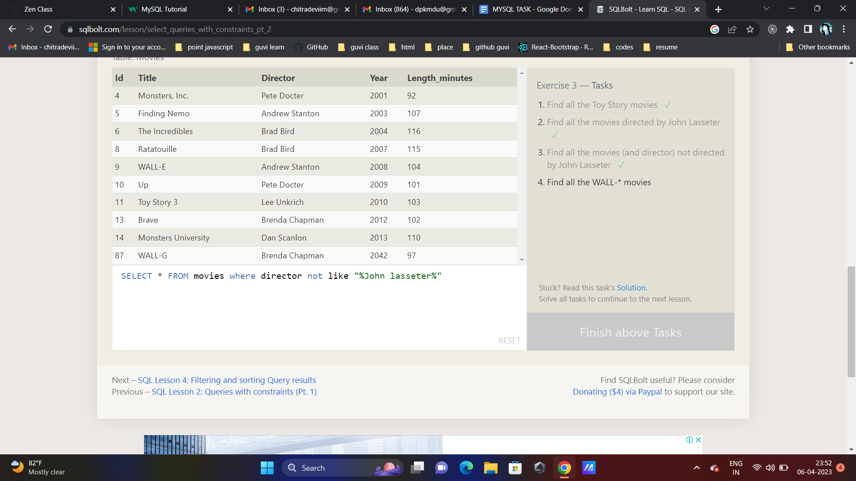

* SELECT * FROM movies where title like "%Wall%"

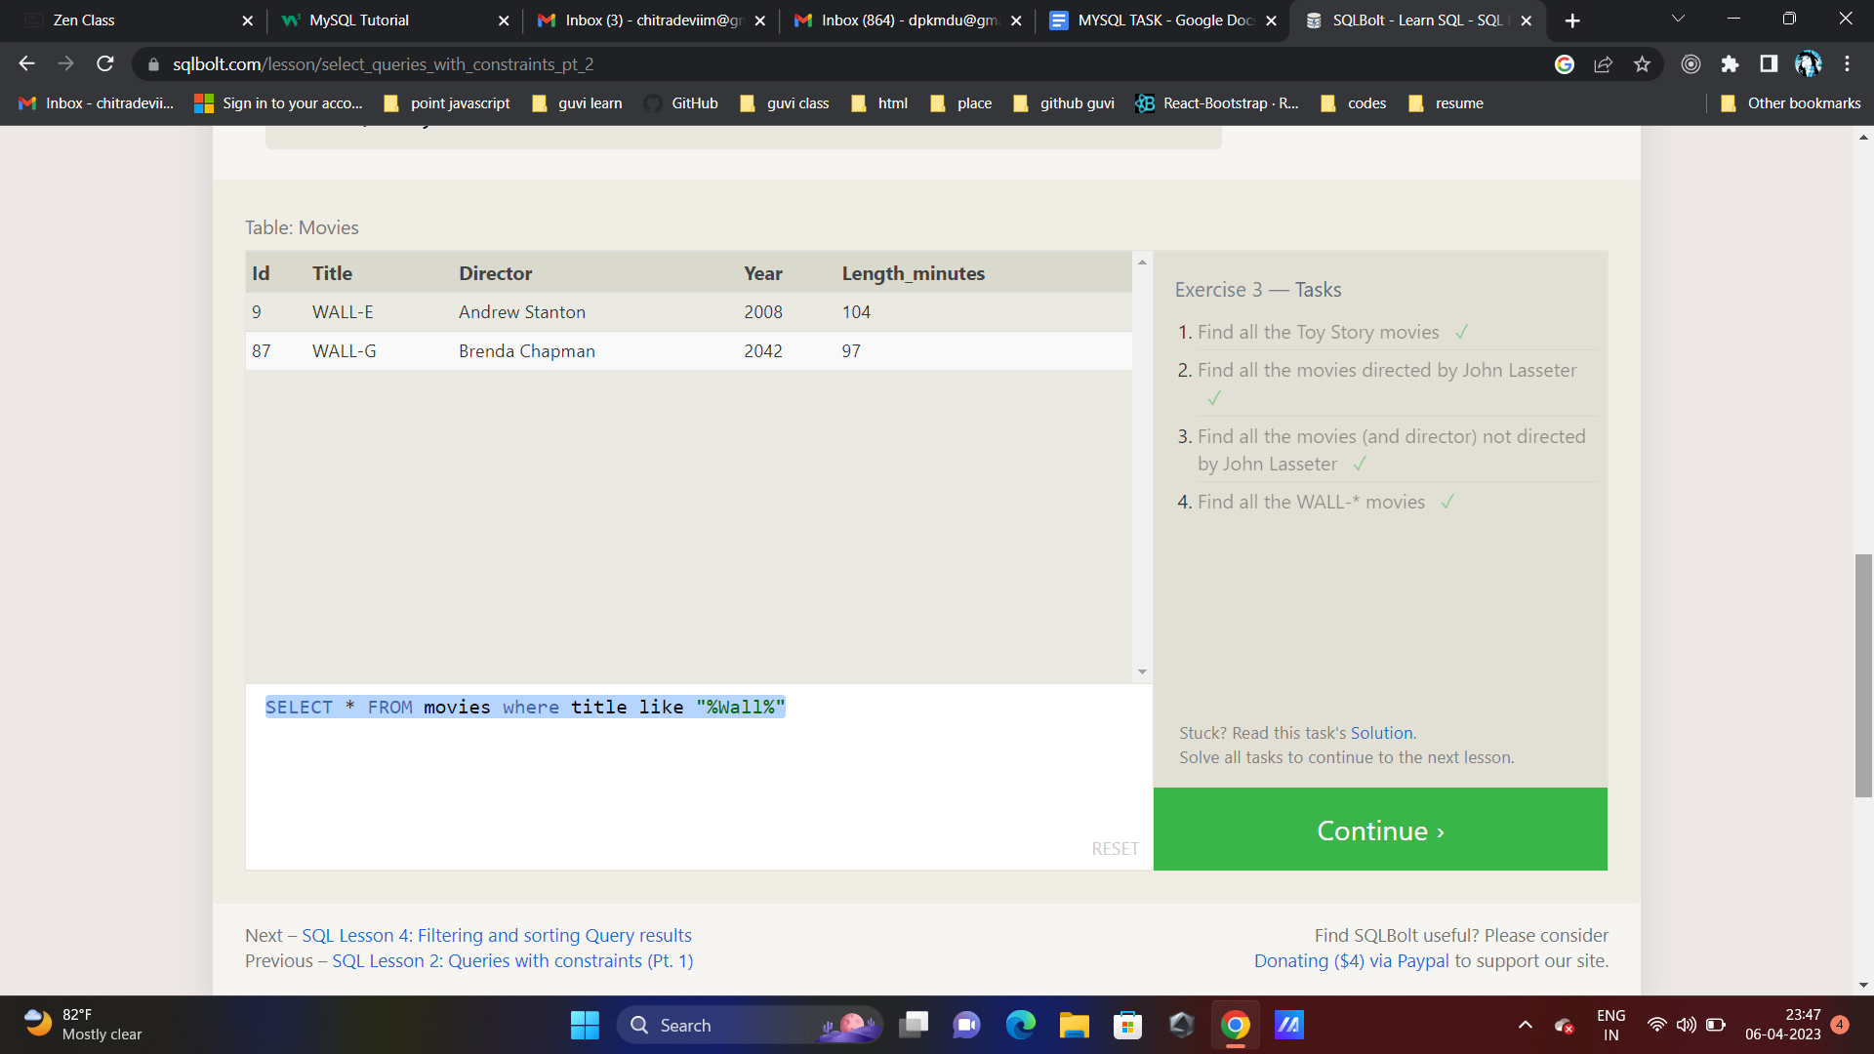

**SQL Lesson 4: Filtering and sorting Query results**

**Exercise 4 — Tasks**

1. **List all directors of Pixar movies (alphabetically), without duplicates**
2. **List the last four Pixar movies released (ordered from most recent to least)**
3. **List the first five Pixar movies sorted alphabetically**
4. **List the next five Pixar movies sorted alphabetically**

SELECT distinct director FROM movies order by director asc

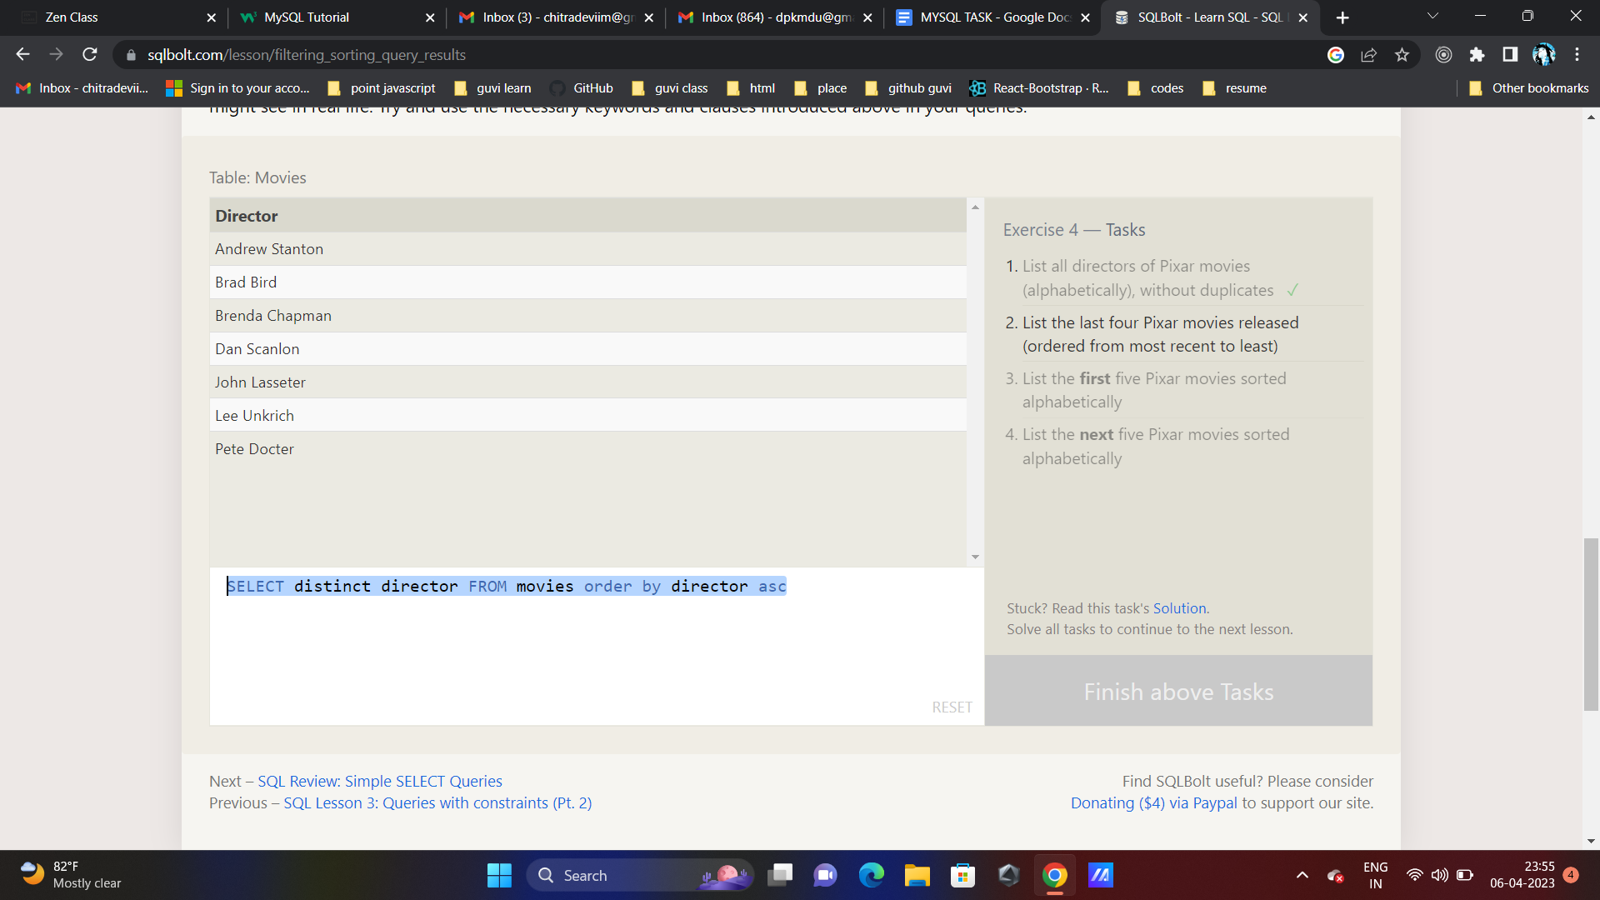

SELECT * FROM movies ORDER BY year DESC LIMIT 4;

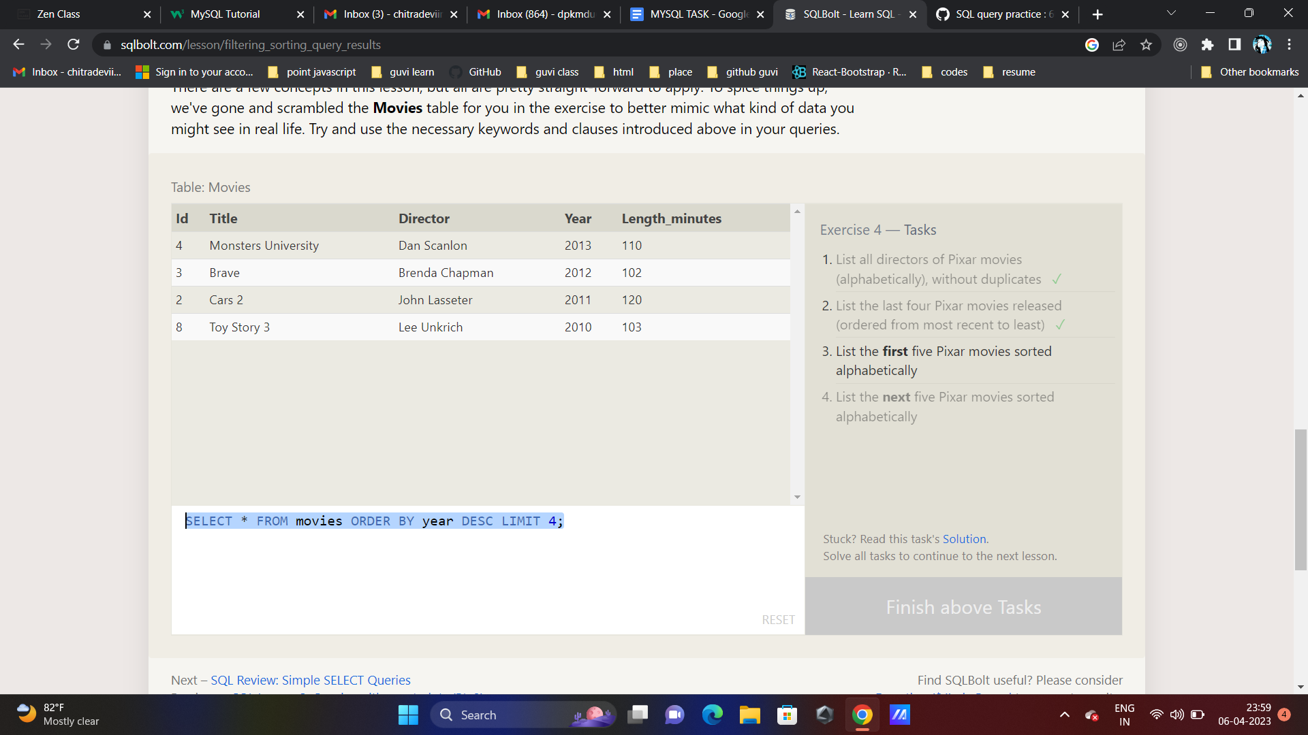

SELECT * FROM movies ORDER BY TITLE ASC LIMIT 5;

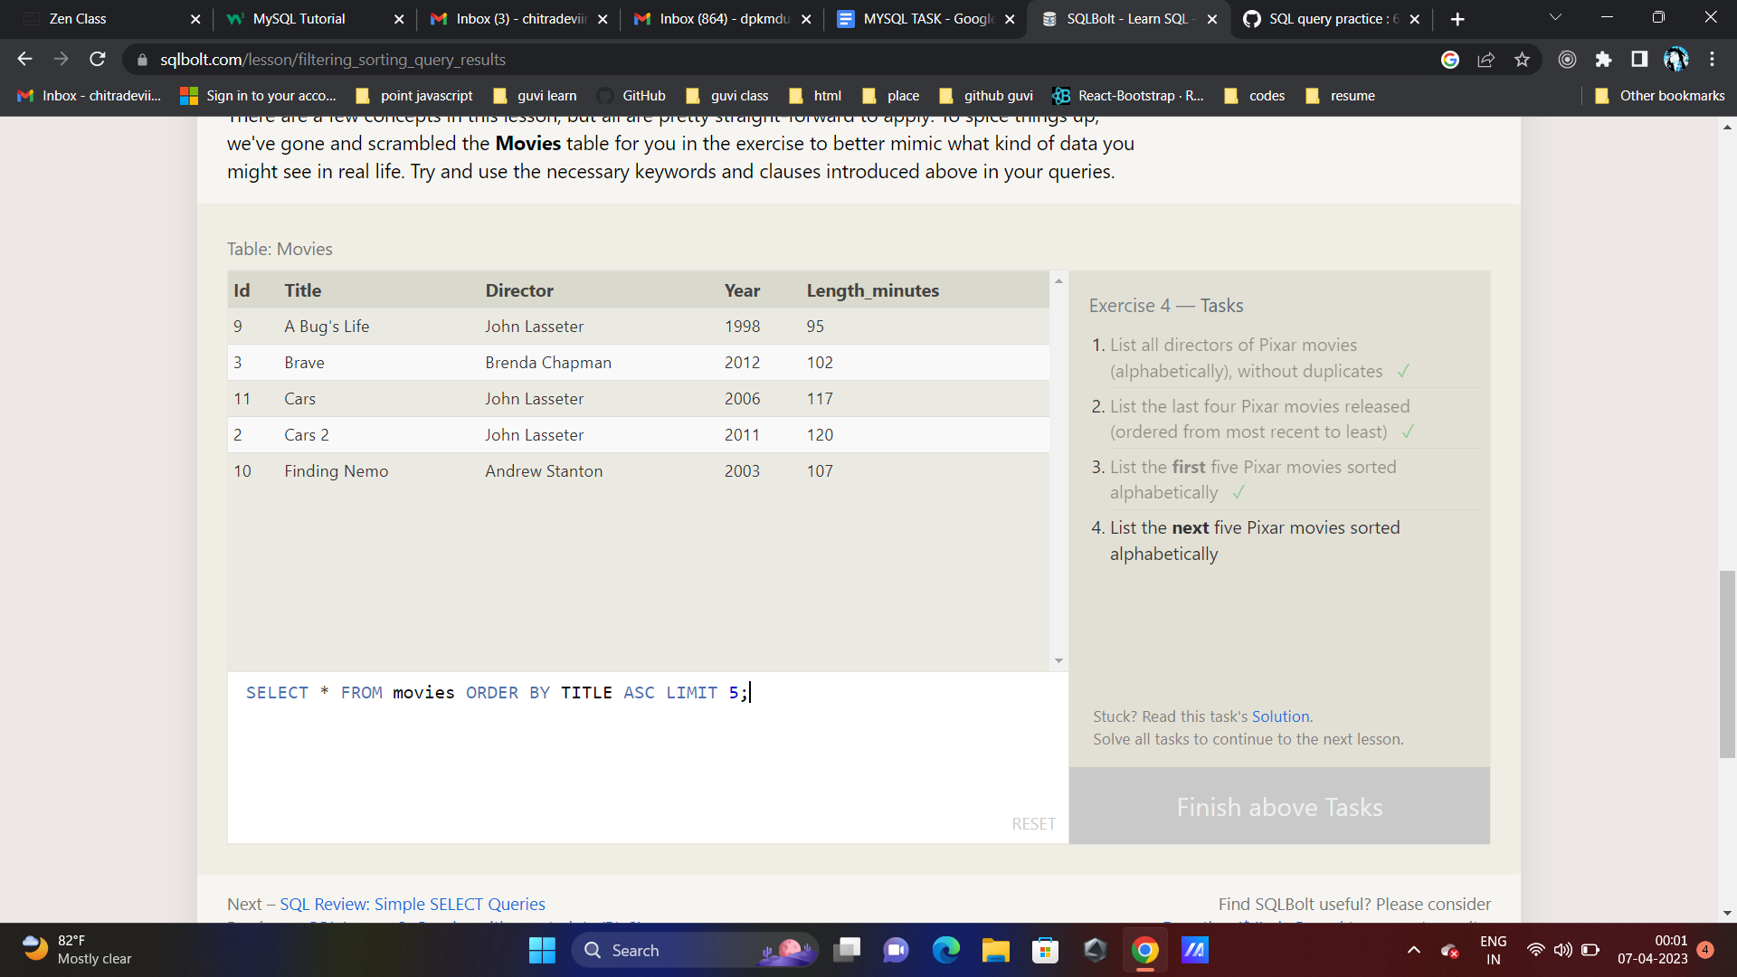

SELECT * FROM movies ORDER BY TITLE ASC LIMIT 5 OFFSET 5

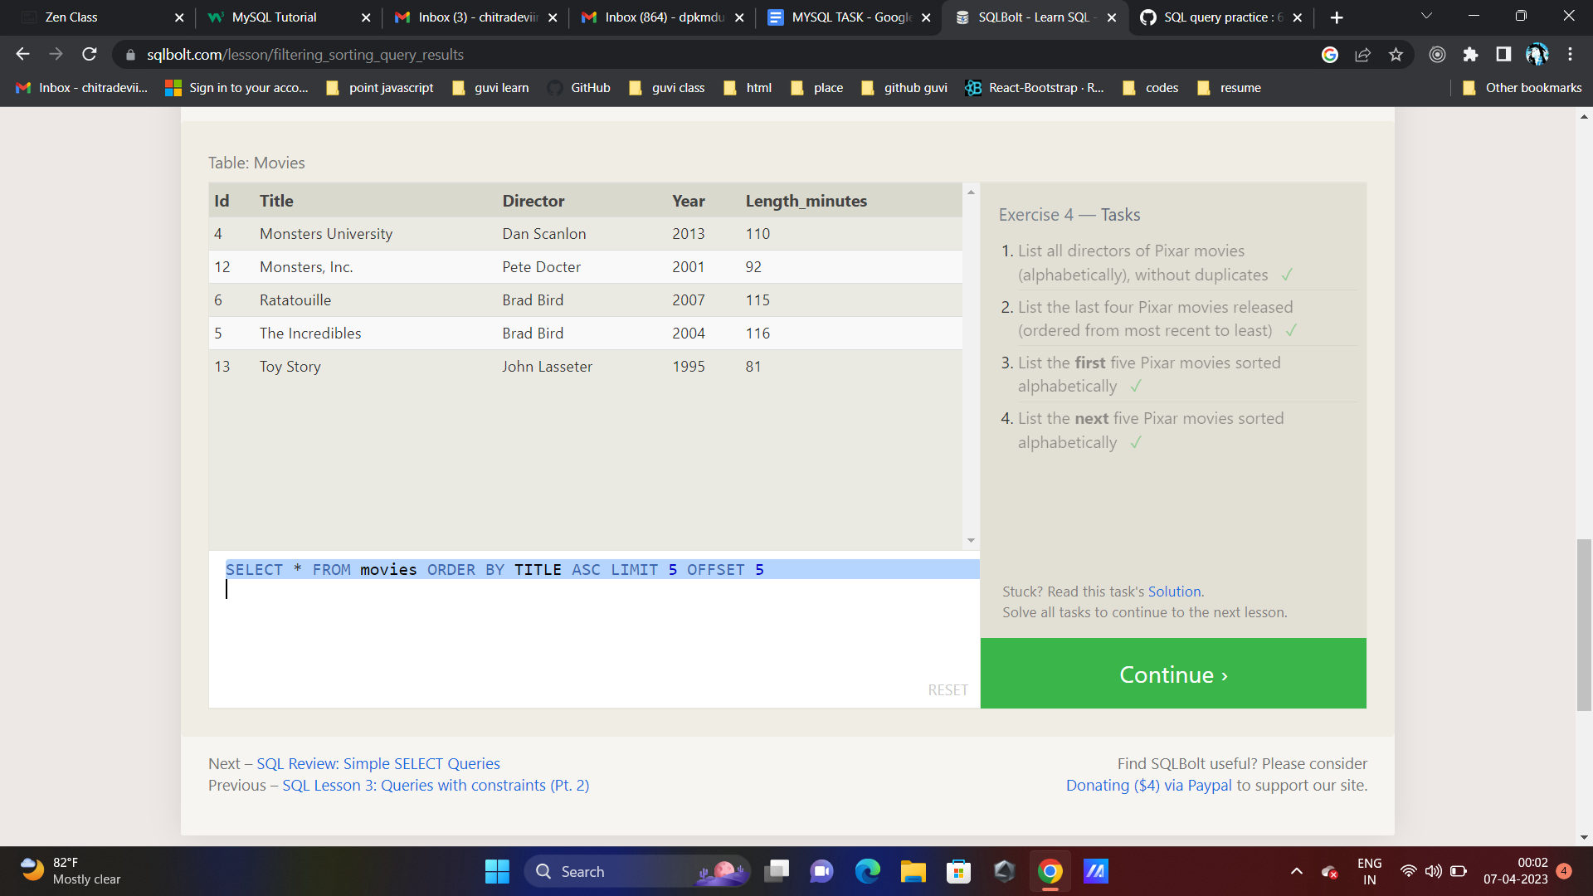

**SQL Review: Simple SELECT Queries**

**Review 1 — Tasks**

1. **List all the Canadian cities and their populations**
2. **Order all the cities in the United States by their latitude from north to south**
3. **List all the cities west of Chicago, ordered from west to east**
4. **List the two largest cities in Mexico (by population)**
5. **List the third and fourth largest cities (by population) in the United States and their population**

SELECT * FROM north_american_cities WHERE country = "Canada"

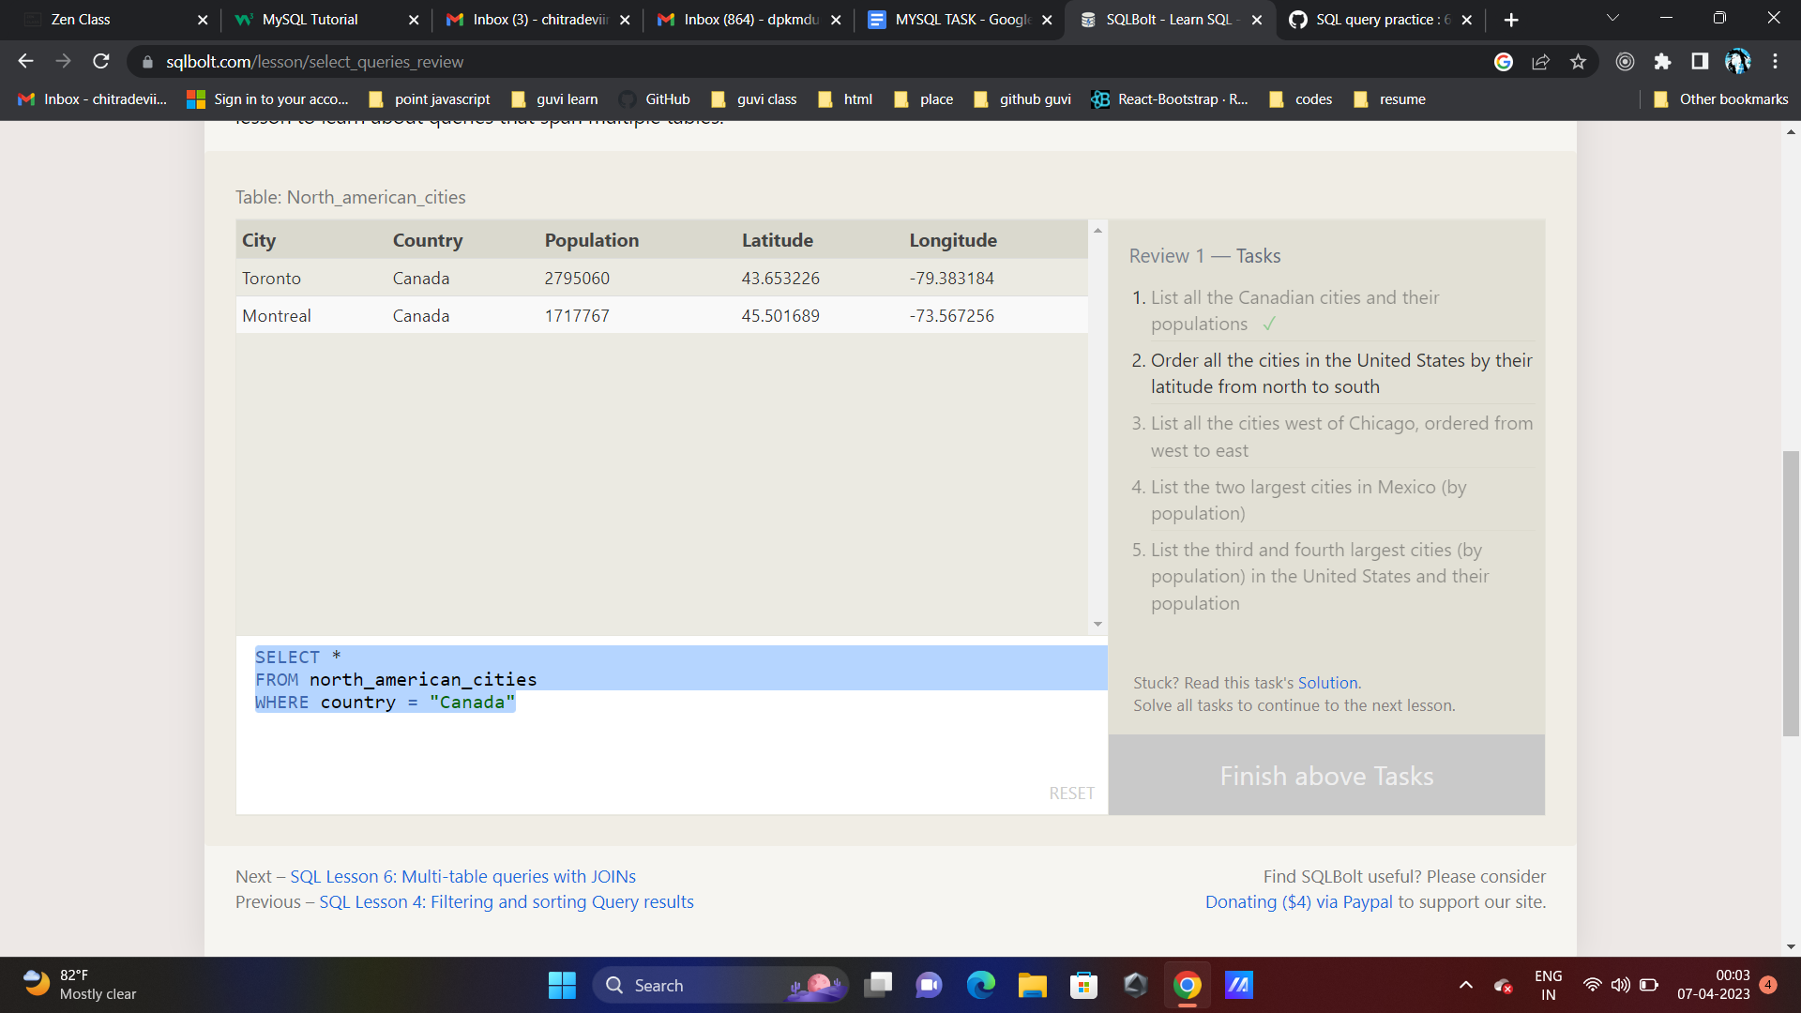

SELECT * FROM north_american_cities WHERE country = "United States" ORDER BY latitude DESC

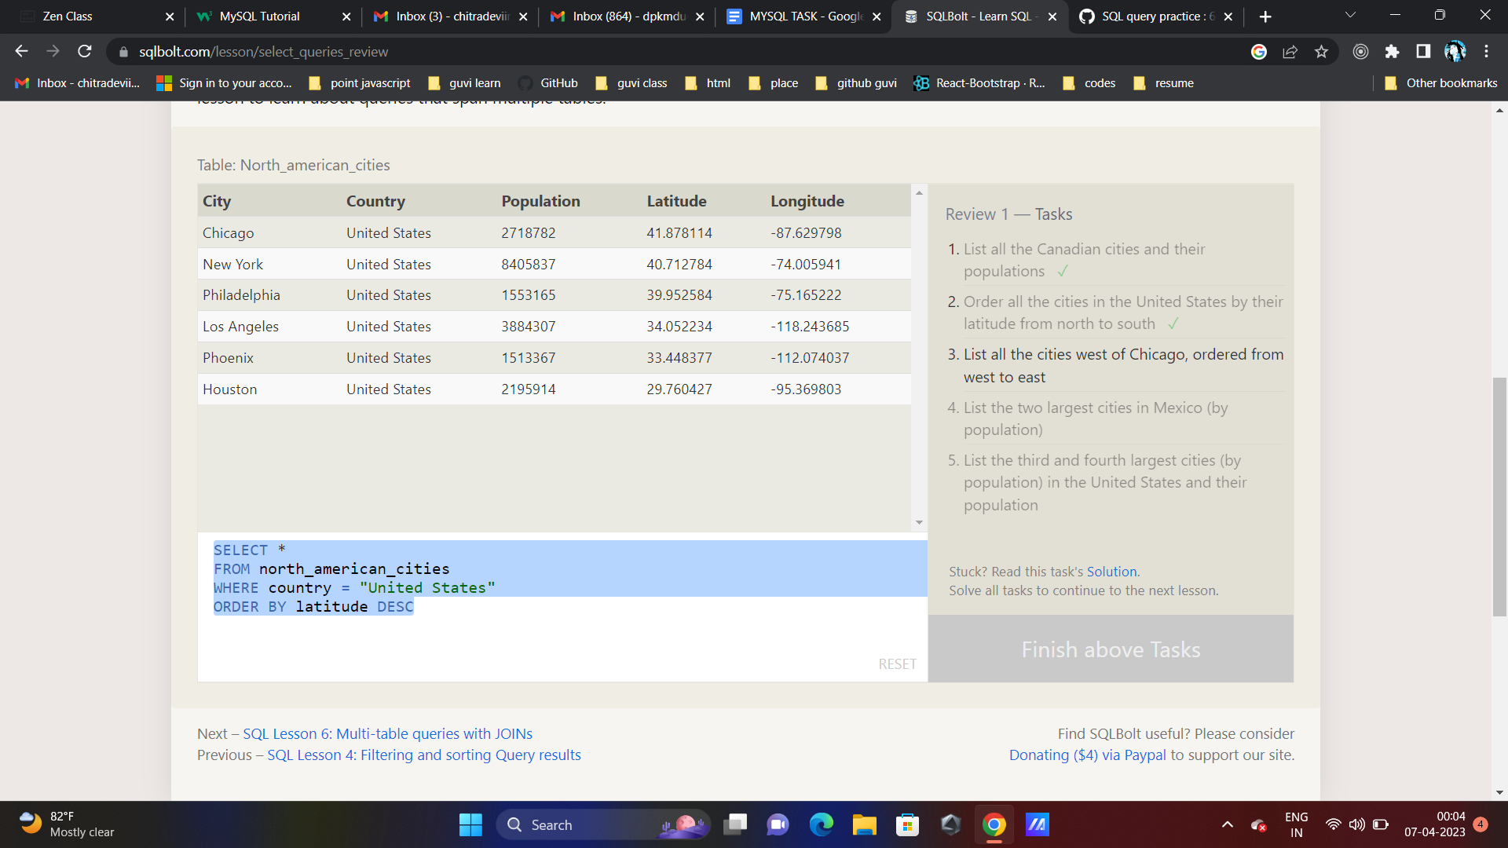

SELECT * FROM north_american_cities WHERE longitude < -87.629798

ORDER BY longitude

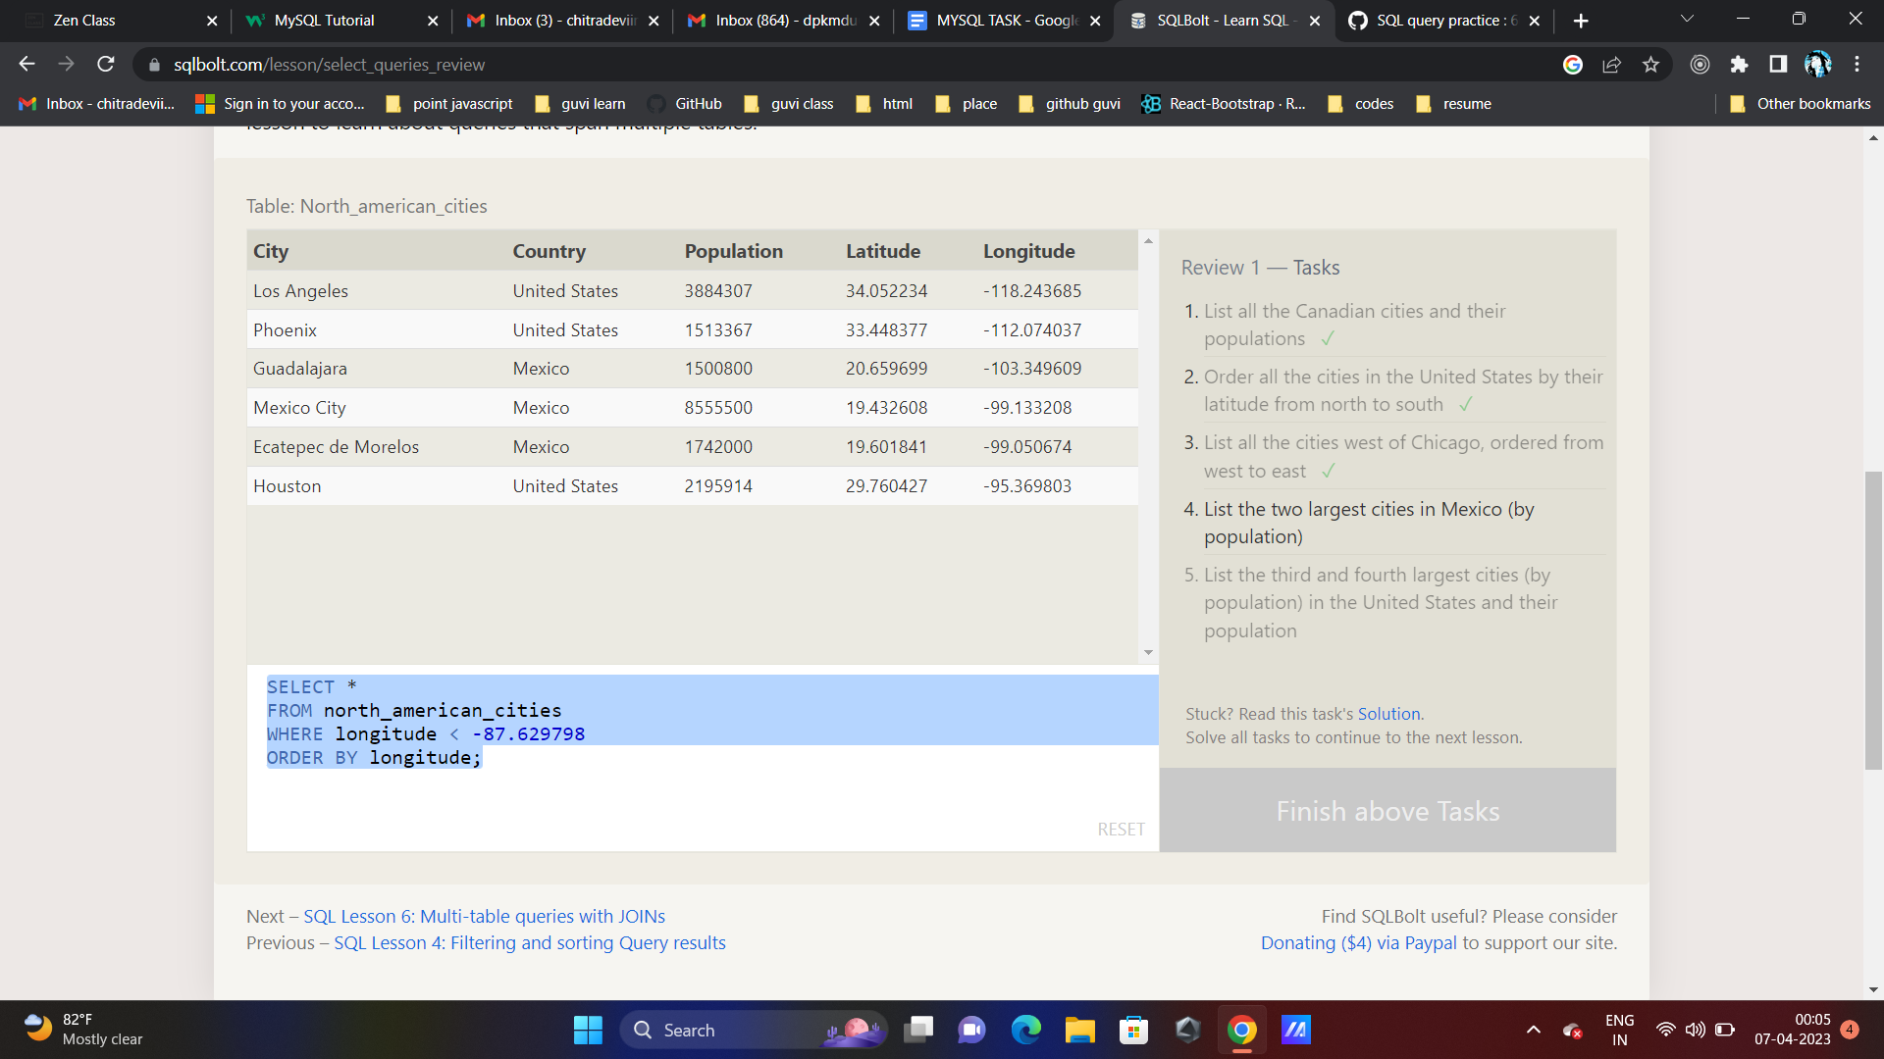

SELECT *

FROM north_american_cities

WHERE country = "Mexico"

ORDER BY population DESC

LIMIT 2

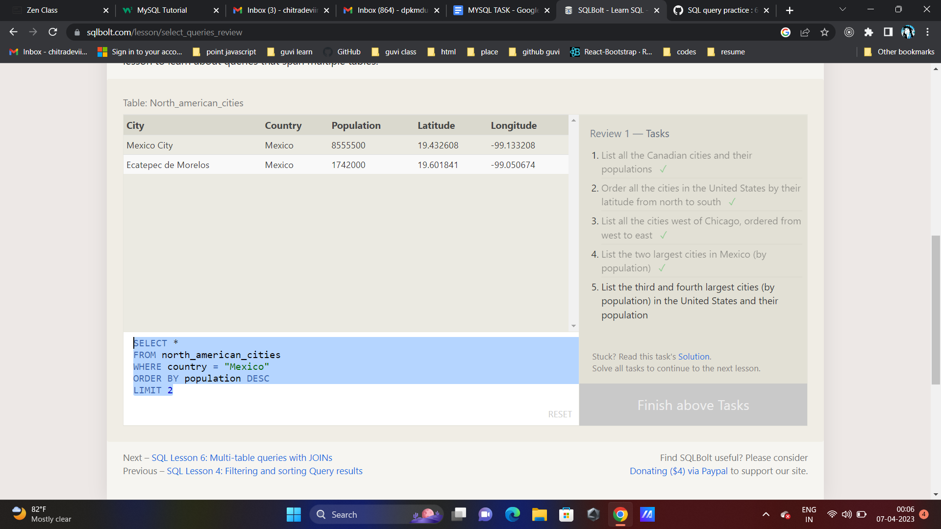

SELECT city

FROM north_american_cities

WHERE country = "United States"

ORDER BY population DESC

LIMIT 2 OFFSET 2;

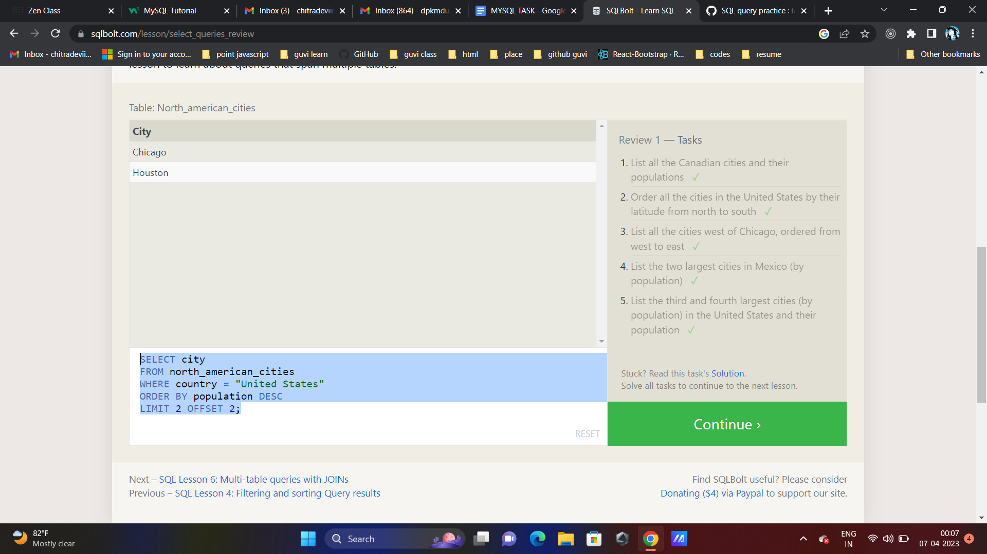

**SQL Lesson 6: Multi-table queries with JOINs**

**Exercise 6 — Tasks**

1. **Find the domestic and international sales for each movie ✓**
2. **Show the sales numbers for each movie that did better internationally rather than domestically**
3. **List all the movies by their ratings in descending order**

SELECT title, domestic_sales, international_sales

FROM movies

INNER JOIN boxoffice

ON movies.id = boxoffice.movie_id

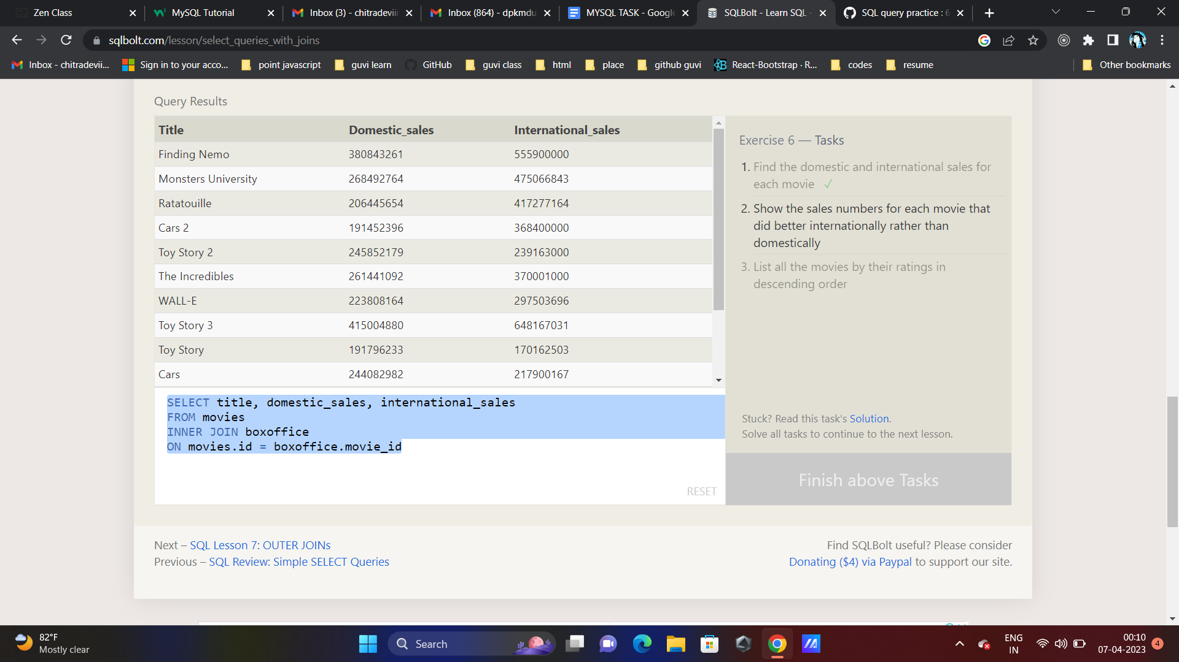

SELECT title, domestic_sales, international_sales

FROM movies

INNER JOIN boxoffice

ON movies.id = boxoffice.movie_id

WHERE international_sales > domestic_sales;

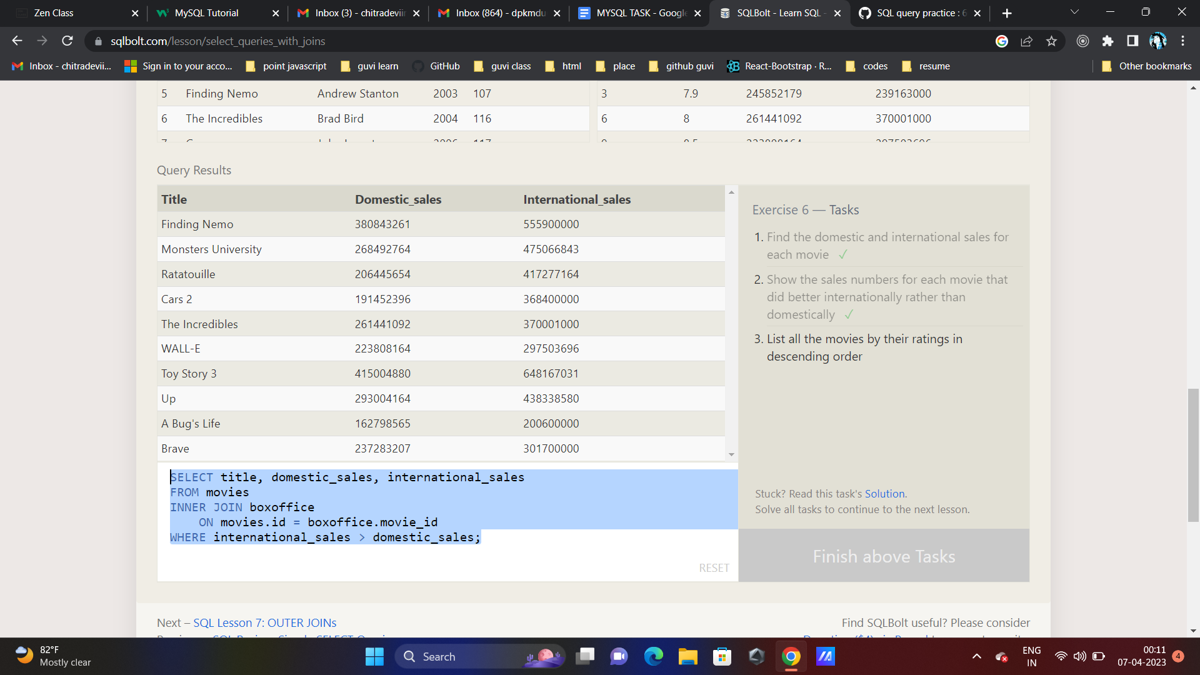

SELECT title, rating

FROM movies

INNER JOIN boxoffice

ON movies.id = boxoffice.movie_id

ORDER BY rating DESC;

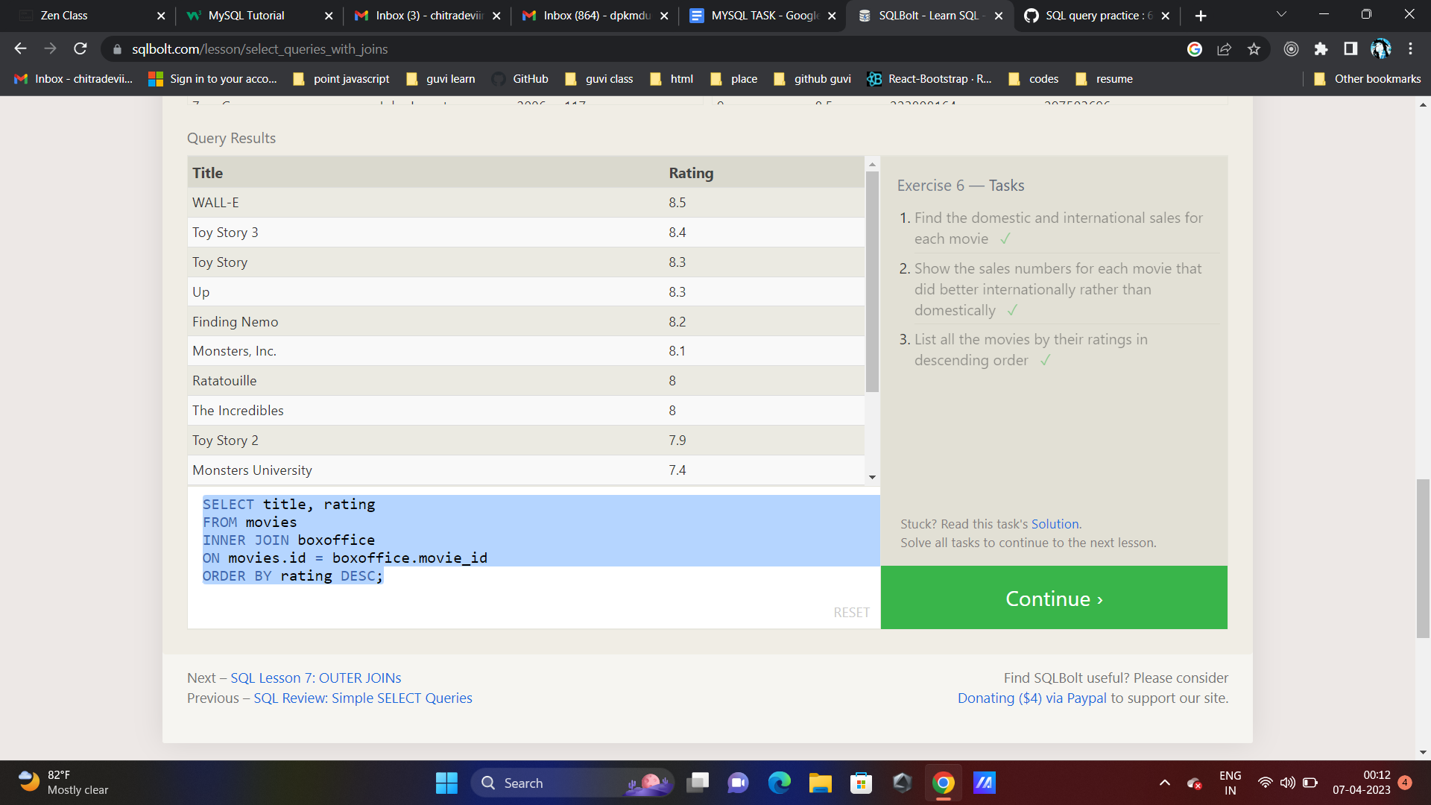

**SQL Lesson 7: OUTER JOINs**

1. **Find the list of all buildings that have employees**
2. **Find the list of all buildings and their capacity**
3. **List all buildings and the distinct employee roles in each building (including empty buildings)**

CT DISTINCT building FROM employees;

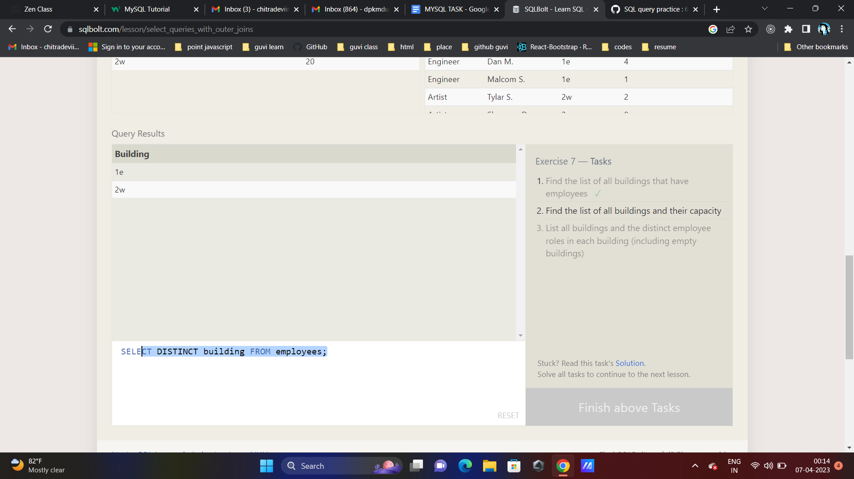

**SELECT * FROM buildings**

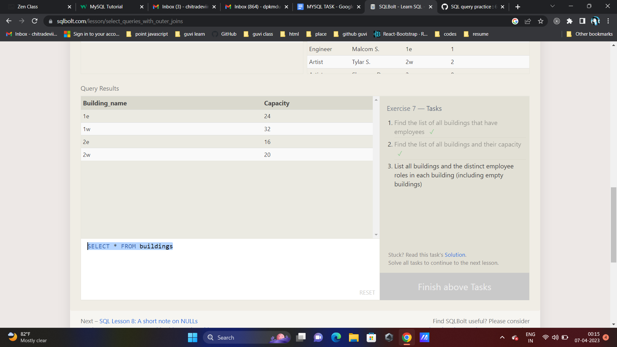

SELECT DISTINCT building_name, role

FROM buildings

LEFT JOIN employees

ON building_name = employees.building;

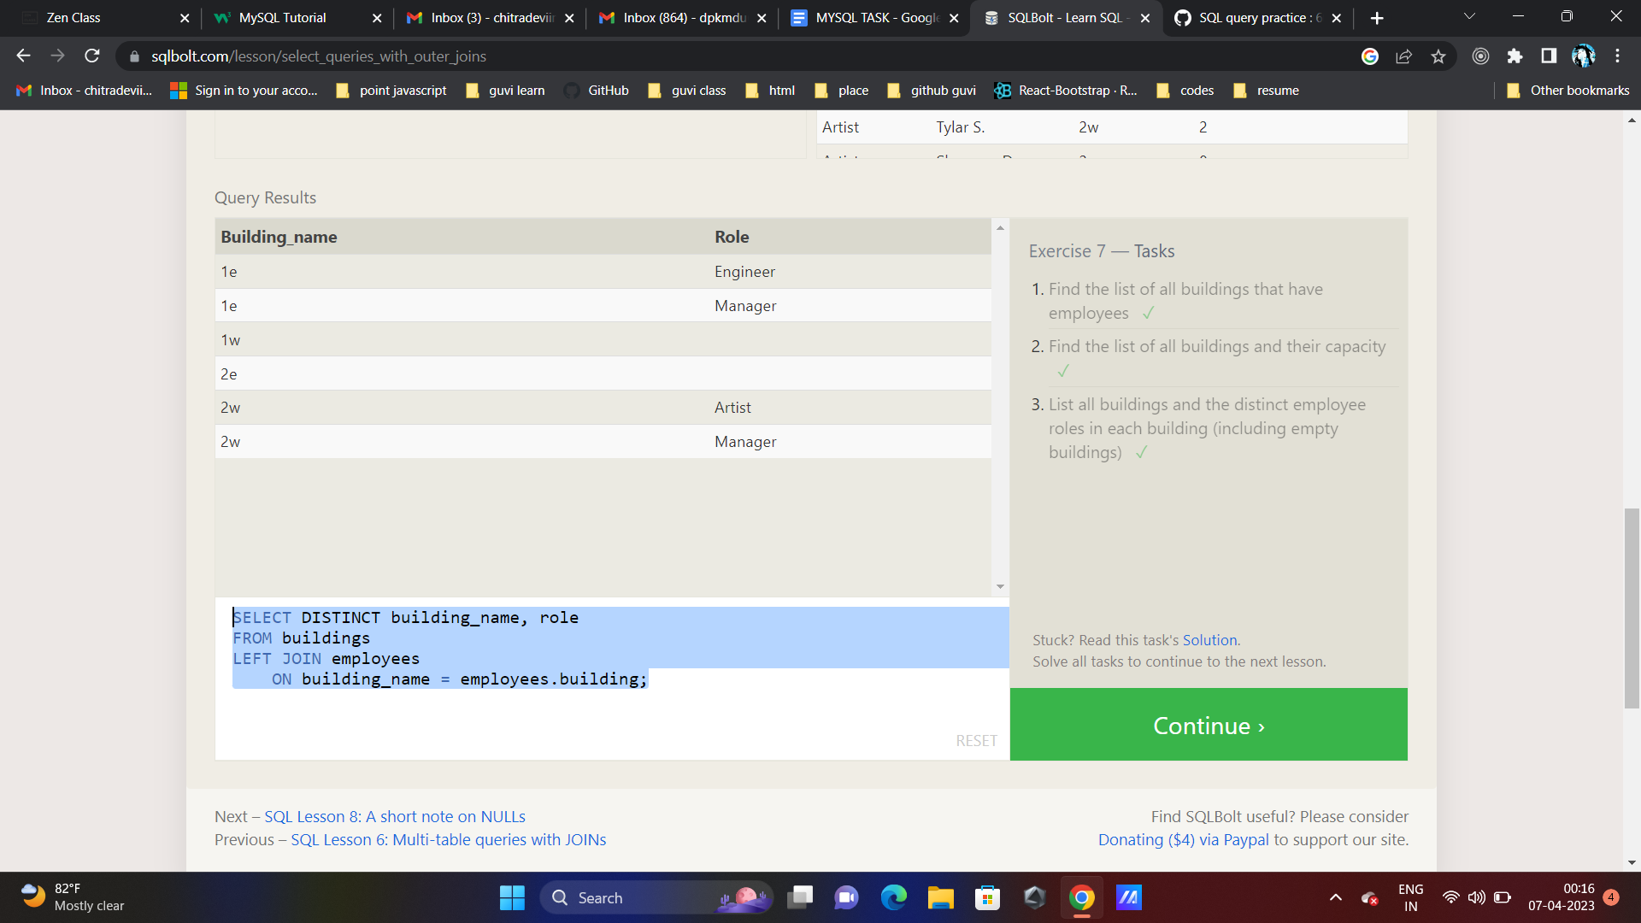

**SQL Lesson 8: A short note on NULLs**

1. **Find the name and role of all employees who have not been assigned to a building ✓**
2. **Find the names of the buildings that hold no employees**

**SELECT name, role FROM employees WHERE building IS NULL**

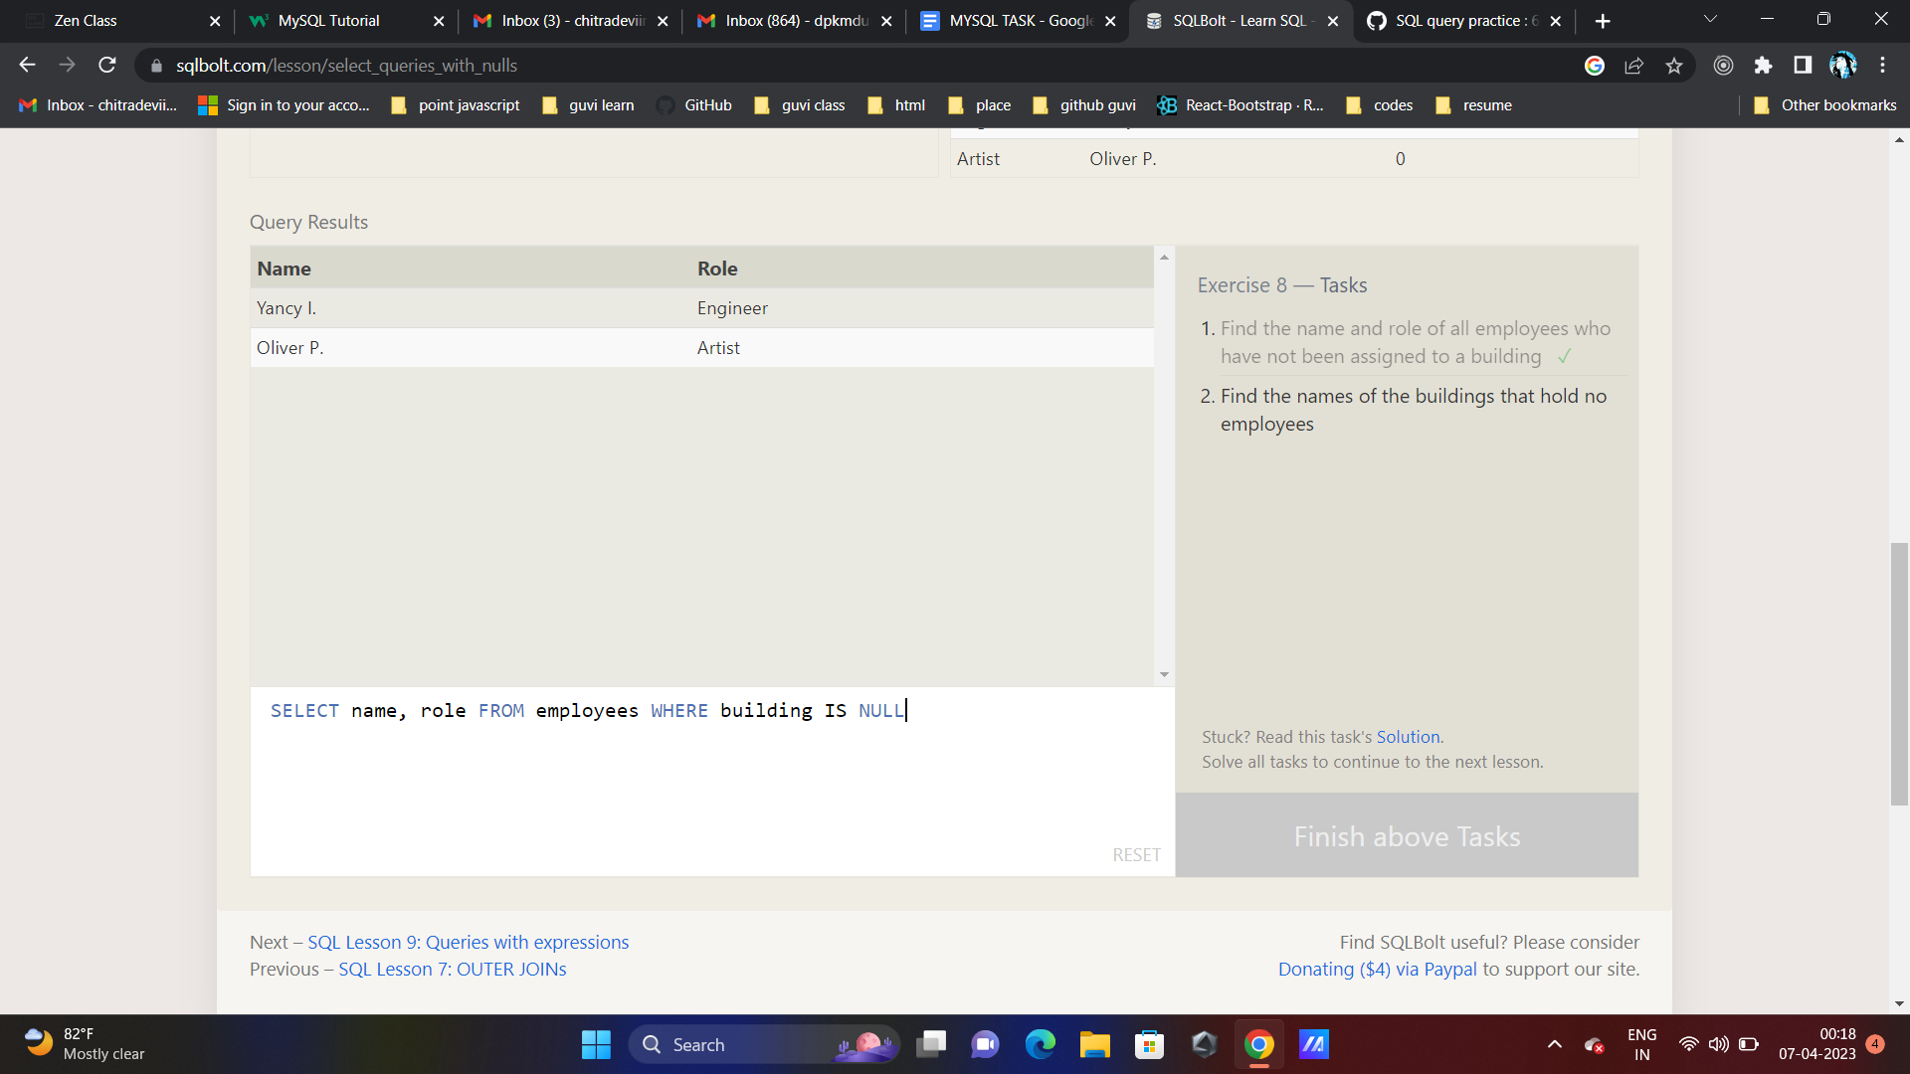

**SELECT DISTINCT building_name**

**FROM buildings**

**LEFT JOIN employees**

**ON building_name = employees.building**

**WHERE employees.building IS NULL**

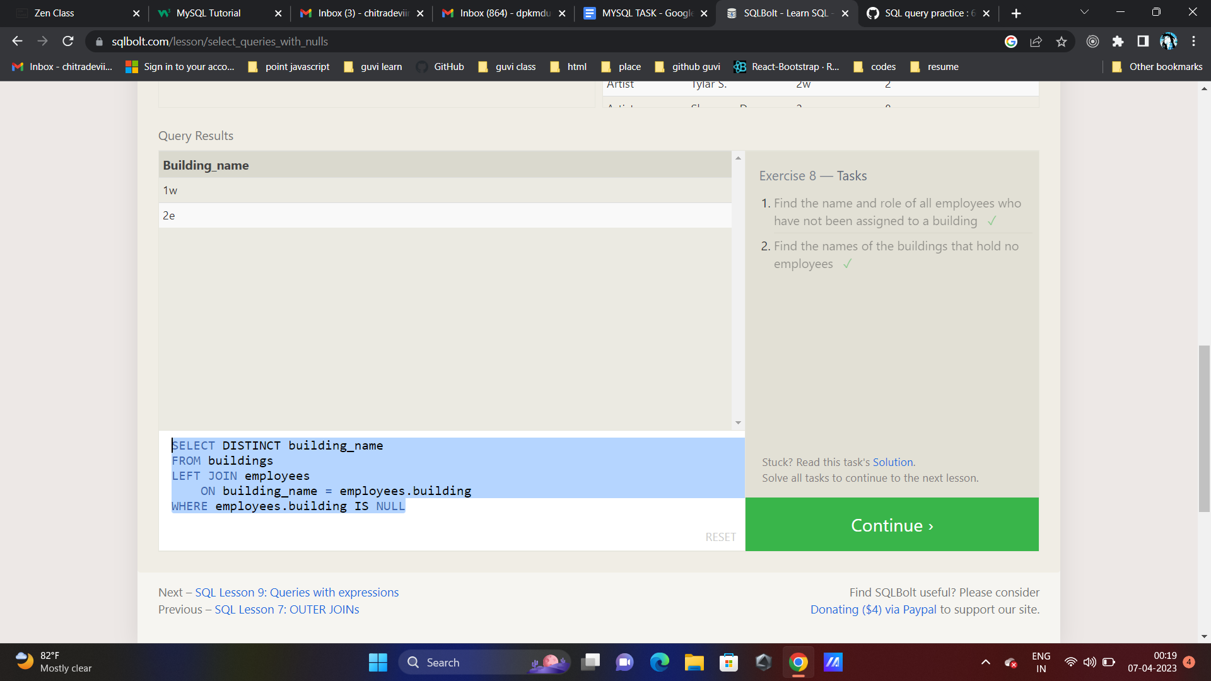

**SQL Lesson 9: Queries with expressions**

**Exercise 9 — Tasks**

1. **List all movies and their combined sales in millions of dollars ✓**
2. **List all movies and their ratings in percent**
3. **List all movies that were released on even number years**

**SELECT DISTINCT**

**title,**

**(domestic_sales + international_sales) / 1000000 AS sales**

**FROM movies**

**INNER JOIN boxoffice**

**ON movies.id = boxoffice.movie_id;**

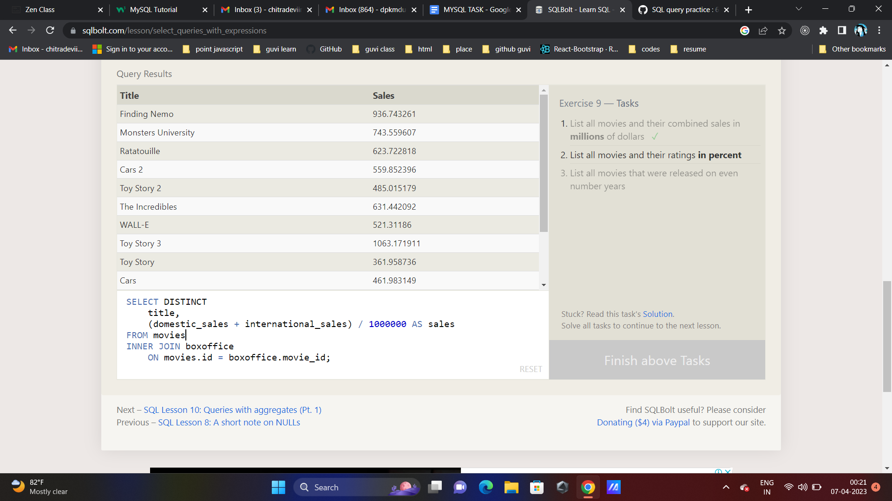

SELECT DISTINCT

title,

(rating * 10) AS PERCENT

FROM movies

INNER JOIN boxoffice

ON movies.id = boxoffice.movie_id;

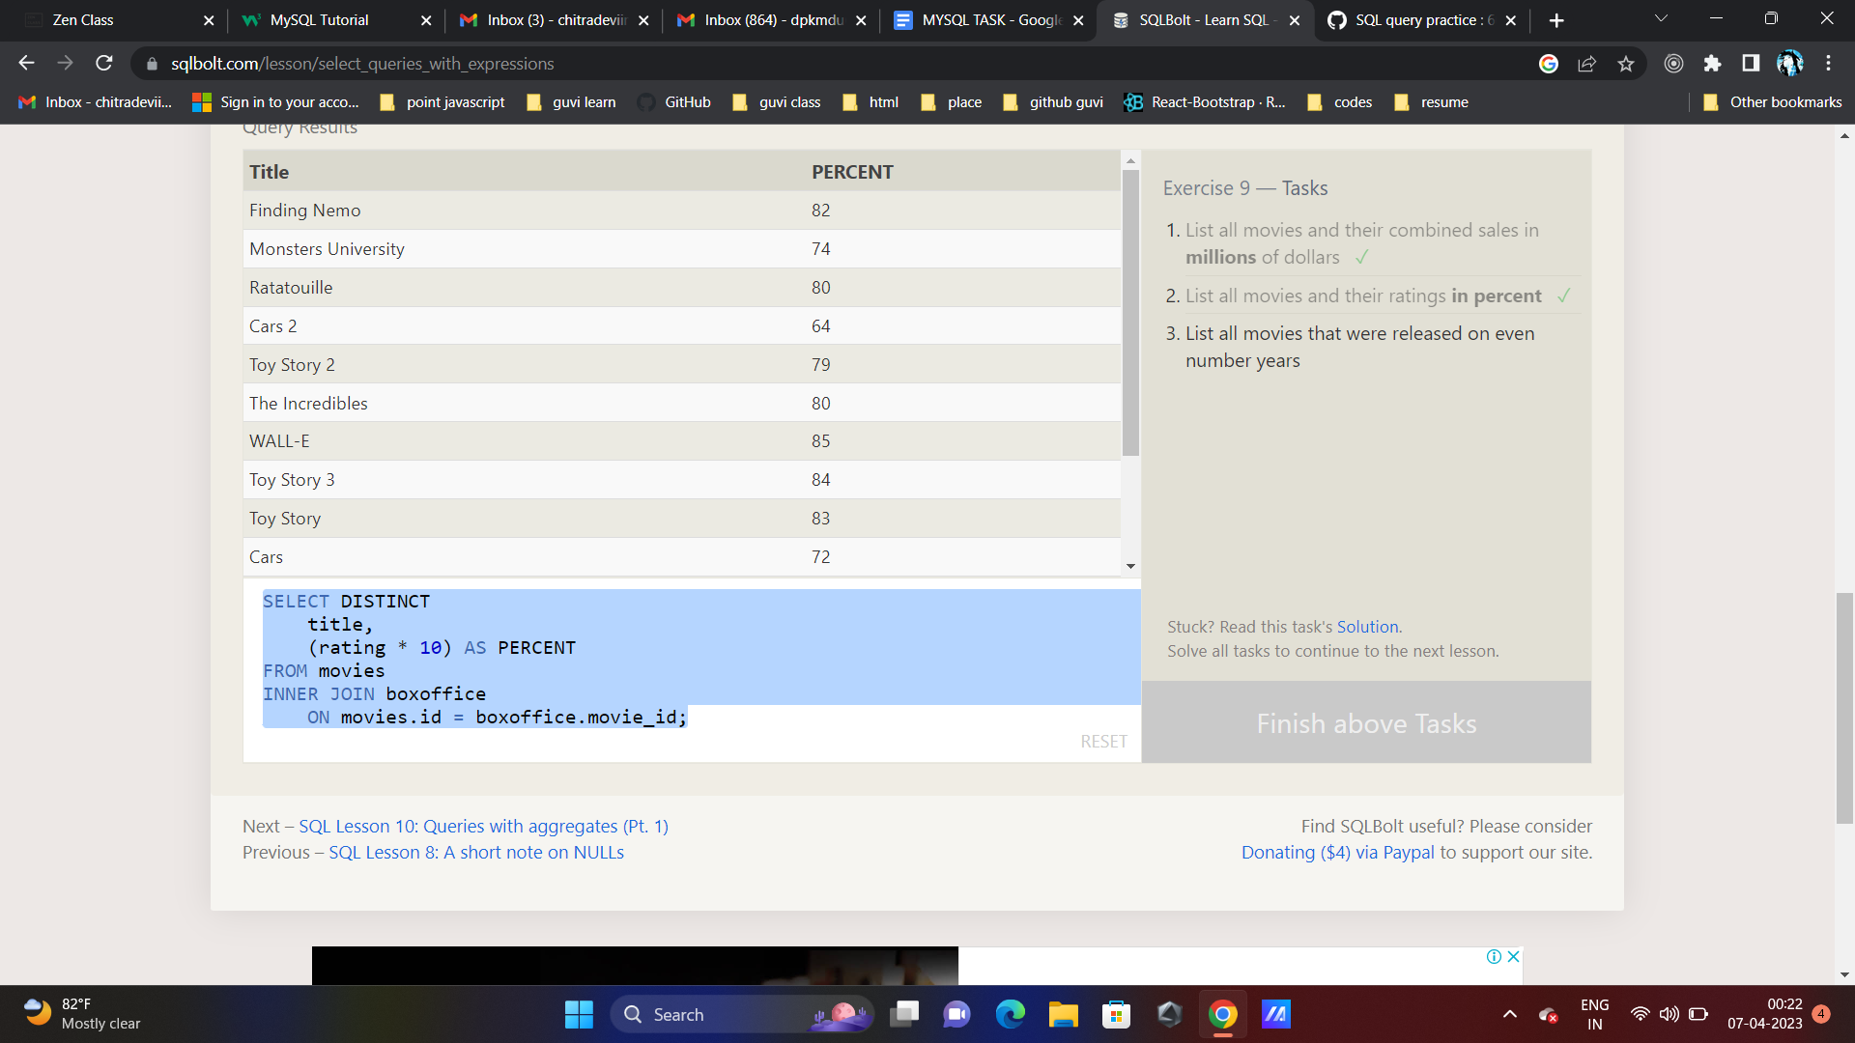

SELECT * FROM movies WHERE year % 2 = 0;

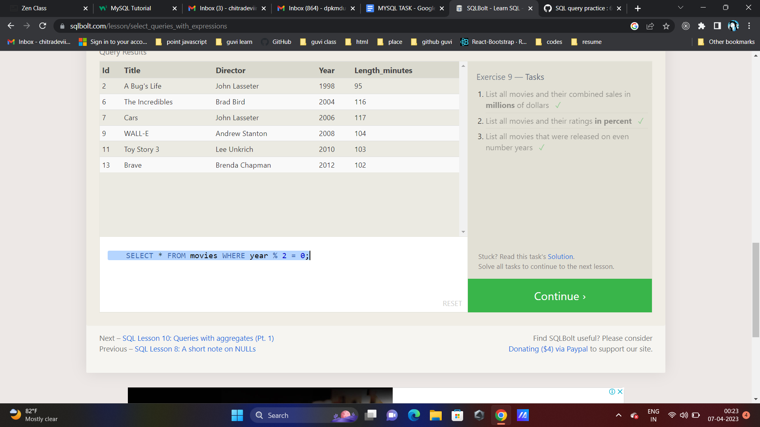

**SQL Lesson 10: Queries with aggregates (Pt. 1)**

[RESET](https://sqlbolt.com/lesson/select_queries_with_aggregates#)

Exercise 10 — Tasks

1. Find the longest time that an employee has been at the studio ✓
2. For each role, find the average number of years employed by employees in that role
3. Find the total number of employee years worked in each building

SELECT name, MAX(years_employed) FROM employees;

SELECT role, AVG(years_employed) as Avg

FROM employees

GROUP BY role;

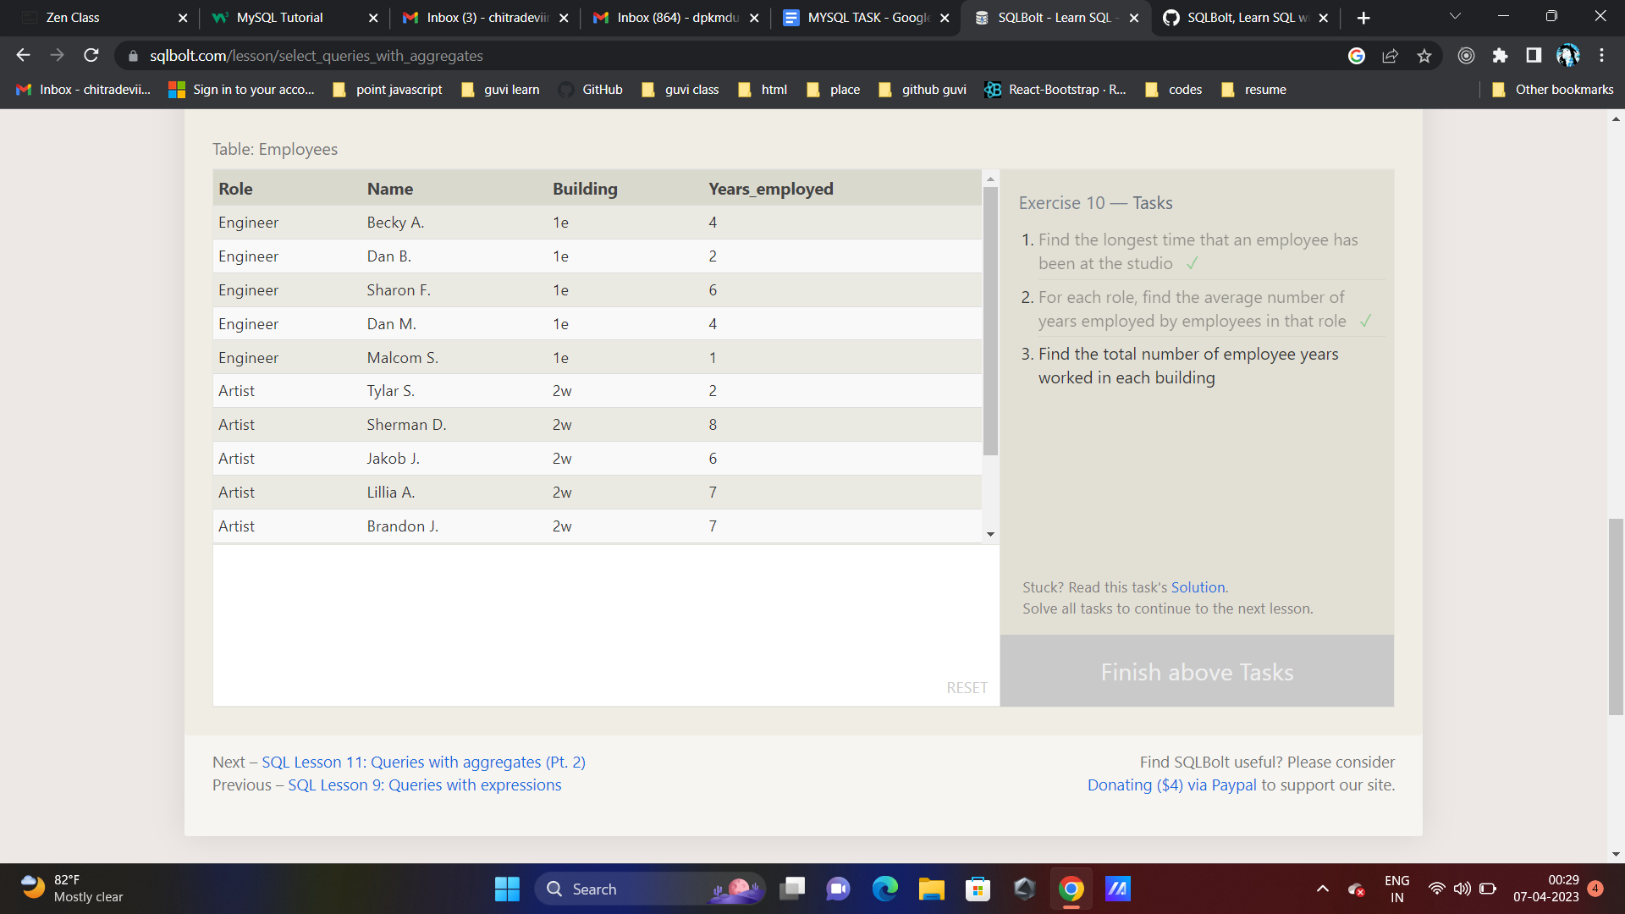

SELECT building, SUM(years_employed) FROM employees GROUP BY building

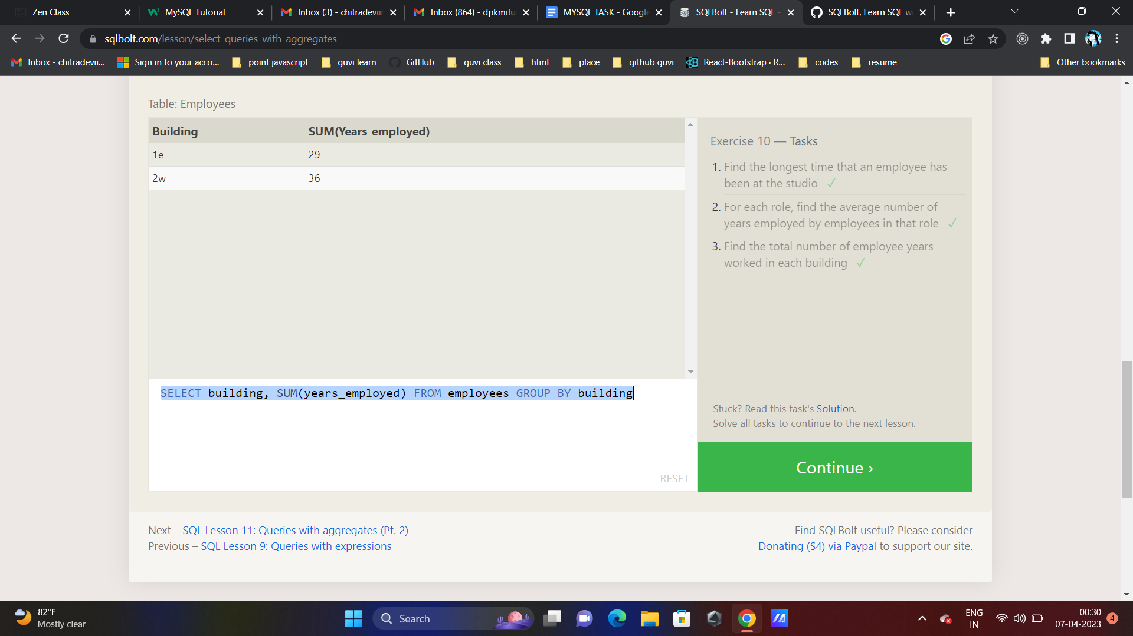

Exercise 11 — Tasks

1. Find the number of Artists in the studio (without a **HAVING** clause) ✓
2. Find the number of Employees of each role in the studio
3. Find the total number of years employed by all Engineers

SELECT COUNT(*) FROM employees WHERE role LIKE 'artist';

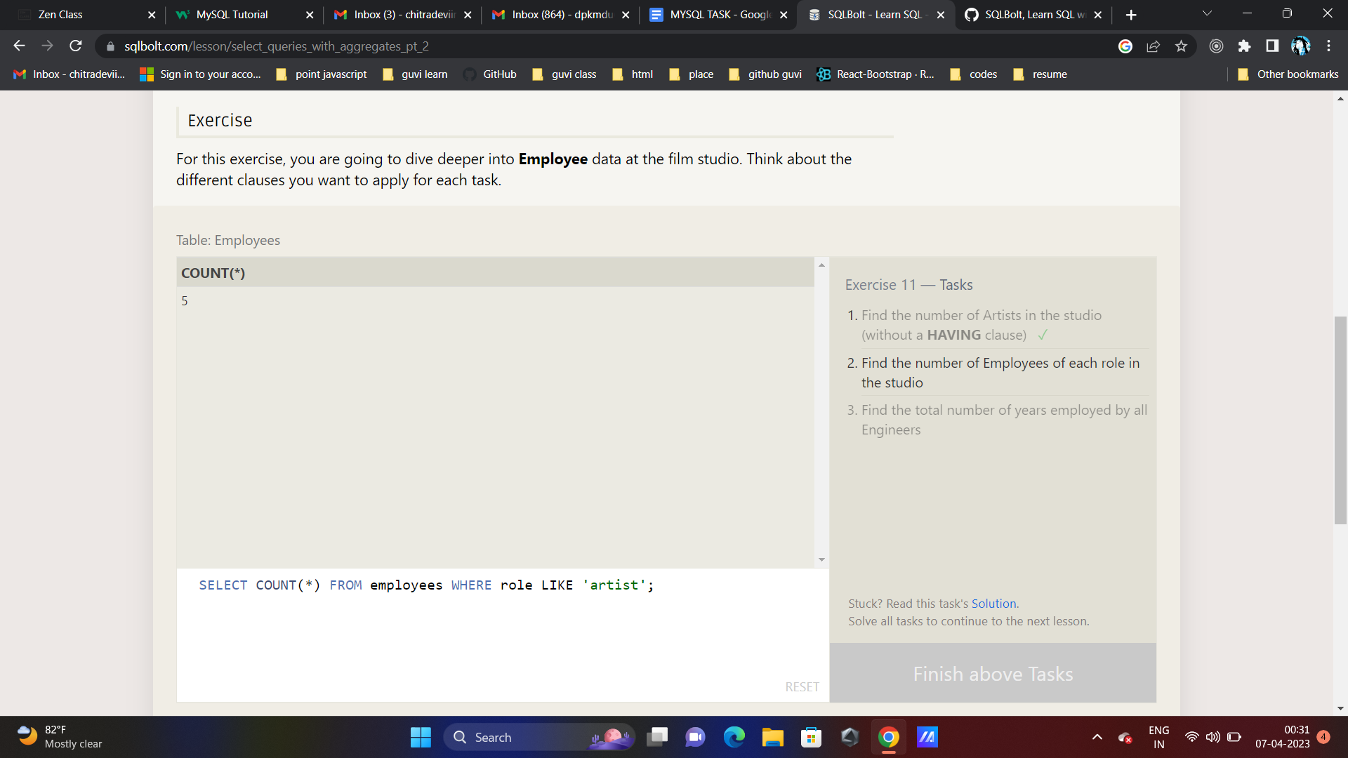

SELECT role, COUNT(name) FROM employees GROUP BY role;

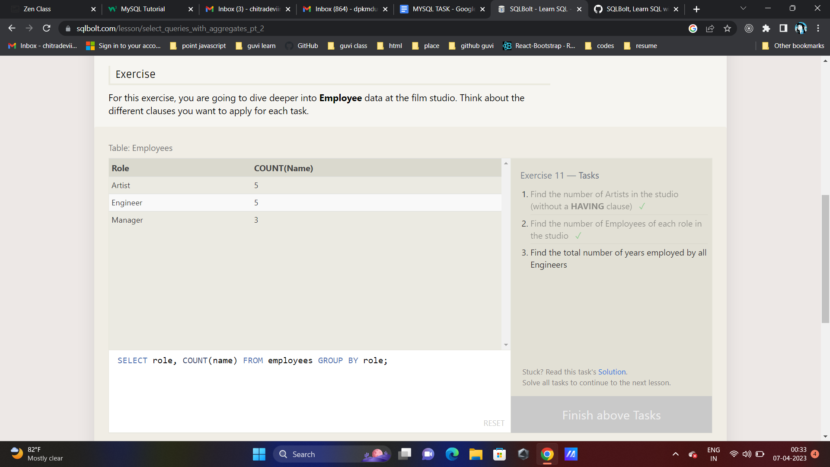

SELECT role, SUM(years_employed) FROM employees

GROUP BY role HAVING role LIKE 'engineer';

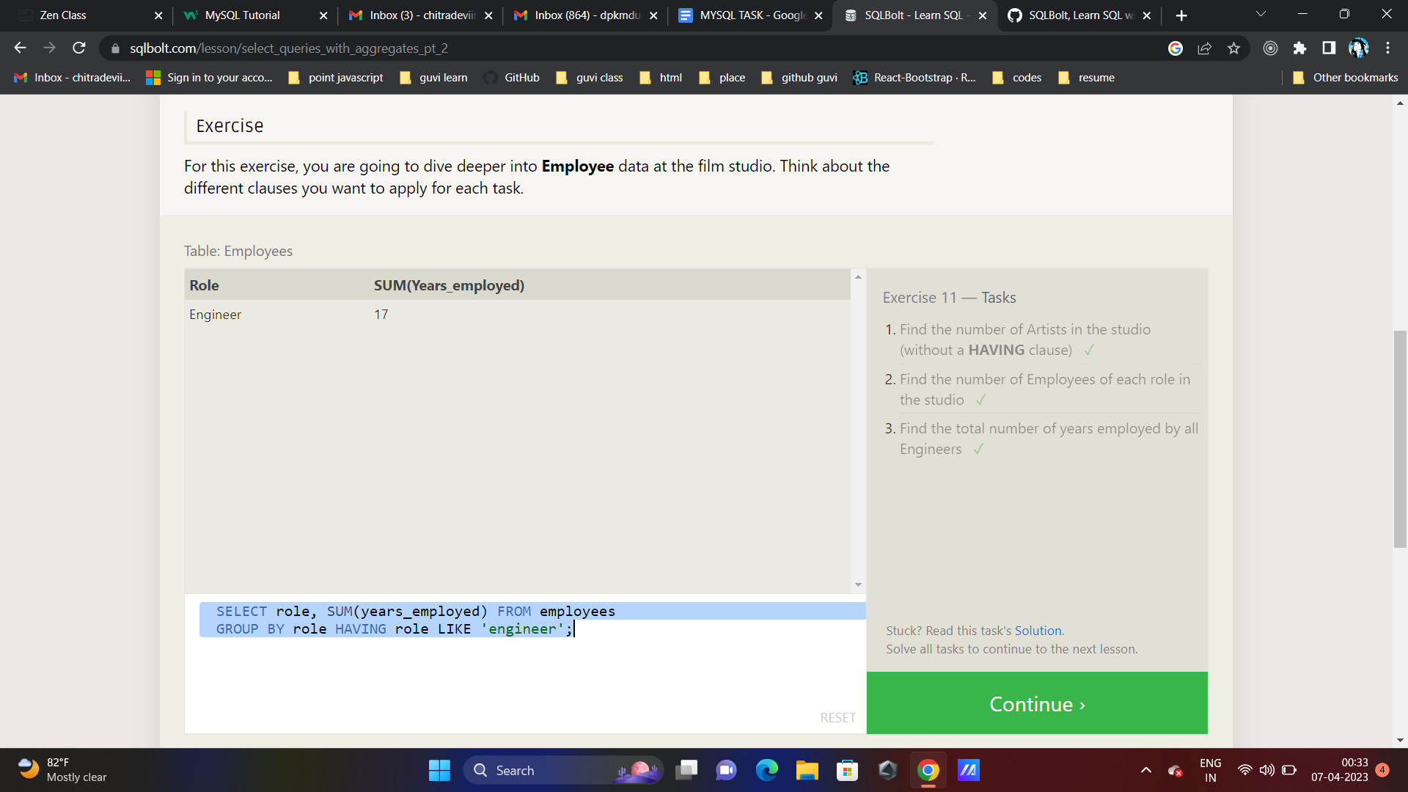

Exercise 12 — Tasks

1. Find the number of movies each director has directed ✓
2. Find the total domestic and international sales that can be attributed to each director

SELECT director, COUNT(*) FROM movies GROUP BY director;

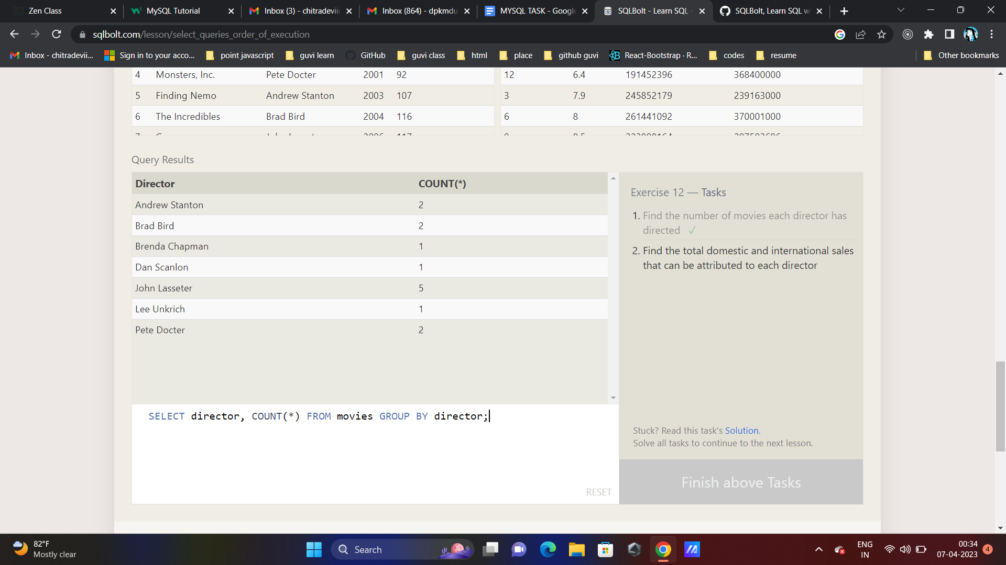

SELECT director, SUM(domestic_sales) + SUM(international_sales) AS Total FROM movies

cross JOIN boxoffice ON movies.id = boxoffice.movie_id

GROUP BY director

